JBAXI Application Programmer’s guide
Version 0.2.6.4
Date: 2014-11-03

Prepared by : | Jani Väinölä and Johan Hallden
Target group : | ECR vendors, terminal vendors and other parties influenced by this specification.

1 References 5
2 Revision Record 5
3 Introduction 8
4 Procedures for using JBAXI 9
4.1 Installation and communication support 9
4.2 General work flow 11
4.3 Error situations 11
4.4 USB rs232 support 11
4.5 Activation of USB port for Linux 11
5 JBAXI Properties 13
5.1 Read properties 13
5.2 Write properties 13
5.3 BaxiEF Properties 17
6 JBAXI Methods 18
6.1 General note on parameters. 18
6.2 Open 18
6.3 isOpen 18
6.4 Close 19
6.5 TransferAmount 19
6.6 Administration 24
6.7 TransferCardData 26
6.8 TransferCardData - BaxiEF 27
6.9 SendTLD 27
6.10 GetTLDTag 28
6.11 SendJson 28
6.12 BiBAdministration 29
6.13 BiBTransaction 29
7 JBAXI Events 30
7.1 General note on events 30
7.2 OnDisplayText 30
7.3 OnPrinterText 30
7.4 OnLocalMode 31
7.5 OnError 33
7.6 OnTLDReceived 33
7.7 OnJsonReceived 34
7.8 OnStdRsp 34
7.9 OnTerminalReady 34
7.10 OnLastFinancialResult 35
7.11 OnCardInfoAll 35
7.12 OnBarcodeReader 38
8 Baxi.ini file 39
9 Common Use Cases 40
9.1 Transactions 40
9.2 TopUp 55
9.3 Gift Card 57
9.4 Group ID 60
9.5 TIP 61
9.6 Send a track 2 card swipe to the terminal: 61
9.7 Set terminal language (Only on Unicapt Terminals) 61
9.8 Receive a card inserted status event 61
9.9 Check host connection (Only on Unicapt terminals) 62
9.10 “Get Customer Info” 62
9.11 “Get Customer Info” with Admin Finish. 64
9.12 Investigating results of last financial transaction. 64
9.13 JSON replacing TLD 65
9.14 JSON and Multiterminal 66
9.15 JSON and VAS (Value Added Services) 66
10 Best practice implementation of security in ECR 67
11 ECR Display Text ID’s 68
11.1 Source : Terminal 68
11.2 Source: Host 68
11.3 Source: Baxi 69
11.4 Source: Card 69
12 Known issue with linux USB 69
13 Appendices 71
13.1 Appendix A – Status codes 71
13.2 Appendix B – Sequence diagrams 73
13.3 Appendix C – Fallback on I9500 76
13.4 Appendix D – TLD not supported 78
13.5 Appendix E – Example integration code 79

References
- Nets proprietary TLD (TypeLengthData) format description
- BiBOpos

Revision Record
DATE | VER. | COMMENTS
2012-05-22 | 0.0.0.5 | Initial version.
2012-06-26 | 0.0.0.6 | Version increment only
2012-07-12 | 0.0.0.7 | Appendix C – Fallback on I9500  Removal of 4.5 (Recovery from hot swap and reboot)
2012-07-17 | 0.0.0.8 | Version increment only
2012-07-17 | 0.0.0.9 | Version increment only
2012-12-13 | 0.0.1.0 | Version increment only
2012-12-18 | 0.0.1.0 | Added Admin codes for dataset and software download.
2013-01-11 | 0.0.1.1 | Changed rs232 library package name from gnu.io.* (RXTX only) to javax.comm.*  This means that any javax.comm rs232 implementation can be used with jBaxi.  Added description of how to use DeviceString property to control USB device monitoring.
2013-01-16 | 0.0.1.2 | Version increment only.
2013-03-05 | 0.0.1.3 | Version increment.  jBaxi now demands a SerialWrapper implantation in eu.nets.baxi.io that wraps the rs232 communications. See the Installation and rs232 support chapters for more details, as well as the JavaDoc files.
2013-04-25 | 0.0.1.4 | Version increment.  jBaxi now gives USB autodetection support at terminal reboot. That is, if the terminal disconnects for some reason and then reconnects again. Then jBaxi will find right com-port and continue communication automatically.
2013-05-03 | 0.0.1.5 | Version increment.  jBaxi is now bundled in two different assemblies. One with nrjavaserial packages inside jbaxi.jar and one with javax.comm packaged inside jbaxi.jar. Also a version without packaging is provided in this release.
2013-05-16 | 0.0.1.6 | Version increment.  jBaxi includes now a EF (extra functionality) – interface. First function there is CardInfoAll that can be accessed through a setting or through a BaxiEF object.
2013-05-28 | 0.0.1.7A | Version increment only.  Bugfixes only.
2013-05-28 | 0.0.1.7B | Updated TransferCardData with 0x40 = Origin Manually.
2013-06-24 | 0.0.1.8 | Version increment.  Bugfixed baxi.ini requirement.
2013-07-04 | 0.0.1.9 | Version Increment.  Bugfixes and improments in the EF – interface.
2013-07-29 | 0.2.0.0 | New versioning adopted. Bug fixes on Linux and in EF – interface
2013-08-14 | 0.2.1.0 | BaxiEF – layer made transparent. (Meaning that it can be used for all operations, not only the extra ones). Bugfix.
2013-09-10 | 0.2.1.1 | Added ECR over IP meaning that JBaxi can now talk to the terminal through TCP/IP. Bugfix.
2013-09-30 | 0.2.1.2 | Auto delete of logs. Number of days to keep the logs is set in baxi.ini: LogAutoDeleteDays=14.  Added a new Serialwrapper for RXTX 2.1.7 which supports 32-bit Linux/Windows only.
2013-10-03 | 0.2.1.3 | Bugfix for ECR over IP.
2013-10-09 | 0.2.1.4 | Bugfix for ECR over IP.  Added logging to file for fatal errors (i.e. baxilogFatal_2013_10_09.log)
2013-11-22 | 0.2.2.0 | Bugfix for slow open() and isOpen()  Added new settings-handling with default values
2013-12-05 | 0.2.2.1 | Fixed problem in reading “\” with the new settings-handling
2013-12-09 | 0.2.3.0 | Upgraded to Java 7, Dropped Java 6 support.  Refactored internal messagequeues  Bugfixing for BaxiEF – layer, ECROverIP, X-Report and settings
2014-03-31 | 0.2.4.0 | Removed javax.comm driver, Refactor on BaxiEF and separated BaxiEF from BaxiCtrl. Added issuerid check on getCustomerInfo on EF-layer. Moved settings read to creation of BaxiCtrl instead of on open(). Bugfixes.
2014-04-09 | 0.2.4.1 | Bugfix on error handling, making baxi to return to right state.
2014-04-11 | 0.2.4.2 | Bugfix on error handling. Added new terminal type (ICMP)
2014-05-08 | 0.2.4.3 | Made BaxiEF getCustoemrInfo issuerID list configurable from outside of baxi.
2014-06-15 | 0.2.5.0 | Added digital assets functionality, added new test-gui made in javafx. Also added onBarcode event.
2014-07-15 | 0.2.5.1 | Bugfixes and upgraded to nrjavaserial 3.9.2
2014-08-11 | 0.2.5.2 | Tidsupervision is now working. TestGUI has new skin. Pre-auth described in Programmer's guide. Baxi returns Localmode Unknown if it gets TLD tag 1016 (Terminal Reboot) during bankmode.
2014-09-25 | 0.2.6.0 | Added Dynamic Currency Conversion (DCC).  Added Nets Digital Asset Framework using JSON
2014-09-29 | 0.2.6.1 | Added AlwaysUseTotalAmountInExtendedLM allowing for TotalAmount to always be used. Bugfix – SendJSON now works with BaxiEF. Added an information header to the logs.
2014-09-30 | 0.2.6.2 | Bugfixes to BaxiEF and Terminal availability after terminal reboot
2014-10-22 | 0.2.6.3 | Bugfixes to BaxiEF and added new MethodReject code to the EF - layer
2014-11-03 | 0.2.6.4 | Bugfixes to BaxiEF

Introduction
NETS have developed JBAXI to simplify integration of EFTPOS solutions to Windows/Linux based point of sale (POS) applications. This implementation is based on the international OPOS standard. The interface is conforming to the existing Norwegian standard for integration of EFTPOS terminals.

JBAXI is a .JAR.

Supported environments:
- Windows XP (32-bit)
- Windows 7 (32-bit & 64-bit)
- Windows 8 (32-bit & 64-bit)
- Linux (32-bit & 64-bit)
- Any jvm that supports Java 7

Furthermore, NETS provides a test-gui for example integration. This is a Maven project done in JavaFX. Read more about it in Appendix E.

Procedures for using JBAXI
JBAXI has four types of communication channels:
- Methods that can be called from the application to typically start a transaction
- Events that are sent from the terminal
- Properties containing information that can be read or written.
- Ini file with configuration parameters

JBAXI has two super states - bank mode and local mode.
In bank mode, the terminal is in control. In local mode, the ECR is in control.
Any method that puts the terminal in bank mode will always result in a local mode event. The local mode event usually indicates the final result of the operation.
JBAXI works as a single instance and two instances towards one rs232 resource is not supported.

Installation and communication support

jbaxi.jar bundled with nrjavaserial
When using the jbaxi.jar assembly with nrjavaserial, there is no need for any special installation of the serial drivers. It should be enough to just add the file “jbaxi.jar” to the java classpath and to set the “baxi.ini” file to hold the right settings and it should work.

jbaxi.jar bundled with tcpserverwrapper
When using the jbaxi.jar with tcpserverwrapper, there is no serialdrivers used. Instead the communication with the terminal is done through tcp/ip. It is important to remember that due to security reasons, the solution was made so that terminal is the client and jbaxi is the server. When an open is made, jbaxi starts listen to connections from the terminal.

To make this assembly to work properly, the terminal need to be configured to connect through tcp/ip to the ip-address of the computer that jbaxi is running on. Also, both the terminal and jbaxi must be configured to use the same port for this communication.

jbaxi.jar bundled with RXTX 2.1.7
When using the jbaxi.jar assembly with RXTX Java needs to know where the native parts of the RXTX are. On Linux this is the file librxtxSerial.so and on Windows rxtxSerial.dll. One way is to put it in an application subfolder named “lib” and starting the application with -Djava.library.path=lib. Furthermore just add the file “jbaxi.jar” to the java classpath and to set the “baxi.ini” file to hold the right settings and it should work.
A start-up .sh-file example on Linux could look like this:
java -classpath .:jbaxi-gui.jar:lib/* -Djava.library.path=lib eu.nets.baxi.gui.JbaxiFrame

jbaxi.jar - Alone
The file “jbaxi.jar”, the serial wrapper jar, the rs232 driver jar and its binary drivers must be made available to the java runtime environment for jbaxi to run successfully.

RS232 Support:

jbaxi.jar itself does not contain an rs232 serial communications implementation, but instead relies on a collection of classes that must be provided in the eu.nets.baxi.io package in a separate jar file provided either by Nets or by the client/vendor/third party.
These classes are:
- SerialDataReceivedListener
- SerialReader
- SerialWrapper
- SerialWrapperNotInitialisedException

Nets currently provides reference implementations for the Sun com-api version (javax.comm) and the nrjavaserial version (gnu.io).

Please investigate these reference implementations and the attached JavaDoc if there is a need to provide another SerialWrapper implementation.

If using nrjavaserial:
- Add the “nrjavaserial-3.9.2.jar”, “jbaxi.jar” and the nrjavaserial wrapper jar (for Nets it is called “SerialWrapper_nrjavaserial.jar”) to the java classpath.

If using rxtx:
- For Windows open rxtx-2.1-7-bins-r2.zip and get "rxtx-2.1-7-bins-r2\Windows\i368-mingw32\rxtxSerial.dll". Put rxtxSerial.dll, jbaxi.jar and the wrapper jar ("Alone\wrappers\SerialWrapper_rxtx.jar") in a "lib" folder and add a path to that folder in your class- and library path. An example of this can be found in "Assembly - rxtx\jbaxiTestGui-windows x86\Javabaxi.bat":
java -classpath .;jbaxi-gui.jar;lib/* -Djava.library.path=lib eu.nets.baxi.gui.JbaxiFrame
Rxtx currently only works on 32-bit Windows and Linux, not 64-bit.

TCP/IP Support
jbaxi.jar itself does not contain an tcp/ip communications implementation, but instead relies on a collection of classes that must be provided in the eu.nets.baxi.io package in a separate jar file provided either by Nets or by the client/vendor/third party.
These classes are:
- ErrorReason
- NotificationType
- TcpServerIOListener
- TcpServerSocketListener
- TcpServerWrapper

Nets current provides an implementation for usage. If you want to use it please add the “TcpServerWrapper. Jar”-file to the java classpath and set the setting “SocketListener” to 1 in the baxi.ini file. Also, the terminal need to be configured to connect through tcp/ip to the ip-address of the computer that jbaxi is running on and both the terminal and jbaxi must be configured to use the same port for this communication (By setting the “SocketListenerPort” setting in the baxi.ini file).

General work flow
- Call a JBAXI method.
- Wait for incoming events from JBAXI.
- When an event gets triggered, act on the parameters of the event function.
- The OnLocalMode event signals a finished transaction.

Error situations
An error event normally occurs if a selected function cannot be performed.
When JBAXI has lost communication with the terminal during a transaction, the OnLocalMode event will be triggered, with the local mode result set to an unknown status. The status of the transaction must then be investigated! This can either be done manually, or via the ECR admin messages “Get Latest Financial Transaction Result” and “Get Latest Transaction Receipt”. These messages are documented in Chapter 5 and 6.

Other than this Baxi logs are generated by the application and can be specified in the baxi.ini file.

USB rs232 support
JBAXI supports monitoring of USB rs232 devices. It supports hot swapping USB payment terminals and if USB payment terminal reboots it will have contact with JBAXI.

For windows:
When the terminal is plugged it will be detected on a comport.(Ingenico drivers must be installed for this)

For Linux:
When the terminal is plugged in, it will be available as a ttyACM* port. This port will have a link to a virtual port. (instructions given in section 4.5)
So even if the terminal is plugged into another USB port on the machine it will be detected on the ttyACM* port and also the same virtual port.

USB rs232 support is always enabled, but its behaviour is controlled by the ComPort property.

ComPort: this property is set to a number, JBAXI will use this as comport number. For linux, this value has to be one more than the actual COMPORT, the reason for this being that in linux comport begin from 0 onwards. For Eg: If the linux port is ttyS40, then the comport value should be 41,

DeviceString: This string is not currently in use in JBAXI when monitoring the ports. However, you can use this property to turn monitoring off. If the DeviceString property is simply an empty string “”, monitoring will be turned off.

Activation of USB port for Linux
- Connect the terminal to the machine via USB.
- Run lsusb to view a list of USB devices connected.
- You will see the usb connected with an ID, the ID will look something like this.
Eg: Bus 008 Device 002: ID 079b:0028 Sagem
- You then need to use the modprobe command to activate the device.
Eg: sudo modprobe usbserial vendor=0×079b product=0×0028
- After this do a dmesg and you will see ttyACM* in the list.You can also verify this in the /dev/ folder.
- Go to /dev/ folder and do an ls to list the ports being used. Check which ports (ttyS*) are used.
- Create a link for the ttyACM0 to a port that does not appear in the list.
Eg: ln -s /dev/ttyACM0 /dev/ttyS40
- You're almost done. In the baxi file add 1 to the comport value to connect eg: use COMPORT=41 for the above example.
- Now try to connect to the terminal via USB.
- If communication is not possible try chown uucp /dev/ttyACM0. Try again.

JBAXI Properties
This list describes the properties that can be read /written in JBAXI.

Read properties
These are available after a successful Open() dialogue.
Name | Type | I/O | Description
Version | String | R | This property is the JBAXI version number.  The format is a string of at least 35 in length containing a detailed version string for the BAXI component.
TerminalType  (old name Term_sw_version) | String | R | This property is:  First 2 bytes terminal type.  Second 2 bytes Sofie protocol version.  It can be read after a successful Open dialogue.
TerminalID | String | R | This property is the terminal ID.  It can be read after a successful Open dialogue.
TerminalDeviceData_TLD | byte[] | R | This property contains TLD tag info retrieved from the terminal at start up. See Ref. 1 for details
MethodRejectInfo | String | R | This property contains a string describing the reason why the last method call has returned 0 (rejected a request).
MethodRejectCode | int | R | This property contains a code describing the reason why the last method call has returned 0 (rejected a request). A list of method reject codes is available in Appendix A.

Write properties
Write properties (I/O = W) must be written before the BaxiCtrl object is instanciated. The order of the write properties are that read into JBAXI are
- Setters. The setters that are set programmatically overwrite all other ways to write the properties.
- baxi.ini – file. If a property is not set through a setter, then JBAXI tries to first find the file baxi.ini to fill in the missing properties, if it is not found, then JBAXI tries to find the file baxi.properties to read in the properties. NOTE: The file names are case sensitive and should only contain lowercase letters.
- Default values. If JBAXI cannot find property values from setters or from an ini – file, then the hardcoded default values will be set. The default values are:
Name | Default Value | Comment
LogFilePrefix | Baxilog
LogAutoDeleteDays | 0 | Autodelete of logfiles is not turned on as default
LogFilePath | C:\baxi\logfiles | On Linux: /var/log/baxi/logfiles
HostIpAddress | 91.102.24.111 | Default is that JBAXI goes to test - host
HostPort | 9670
VenderInfoExtended | BBS;Retail;02.13.01;57807343803
BaudRate | 9600
ComPort | 1 | JBAXI uses comport 1 as default
DeviceString | SAGEM MONETEL USB Telium | Device String for ingenico terminals
TraceLevel | 4 | Rigorous logging as default
IndicateEotTransaction | 1
CutterSupport | 0 | CutterSupport is not turned on as default
PrinterWidth | 24
DisplayWidth | 20
PowerCycleCheck | 0 | PowerCycleCheck is not turned on as default
TidSupervision | 0 | Tidsupervision is not turned on as default
AutoGetCustomerInfo | 0 | AutoGetCustomerInfo is not turned on as default
TerminalReady | 0 | TerminalReady is not turned on as default
UseDisplayTextID | 1
UseExtendedLocalMode | 1
UseSplitDisplayText | 0 | UseSplitDisplayText is not turned on as default
SerialDriver | Nets
CardInfoAll | 0 | CardInfoAll is not turned on as default
SocketListener | 0 | SocketListener is not turned on as default
SocketListenerPort | 6001
AlwaysUseTotalAmountInExtendedLM | 0 | AlwaysUseTotalAmountInExtendedLM is not turned on by default

Below is a more detailed description of the writable JBAXI properties:
Name | Type | I/O | Description
LogFilePrefix | String | R+W | A string which will be the prefix of the log file name. The log file name will end with the current date.
LogFilePath | String | R+W | The path to the wanted log directory.
TraceLevel | int | R+W | Accepted values are valid trace levels. Ex 2.
BaudRate | int | R+W | Accepted values are valid baudrates. Ex 9600.
ComPort | int | R+W | Accepted values are com ports (1 to 9). Ex 1.
HostPort | int | R+W | Accepted value is an int in the normal TCP/IP port number range (0 to 65536).
HostIpAddress | String | R+W | Accepted value is a string containing an ip address, e.g. 192.168.1.1
IndicateEotTransaction | int | R+W | Accepted values are 0 or 1. 0 means no EOT indication.
CutterSupport | int | R+W | Accepted values are 0 or 1. 0 means no cutter support.
PrinterWidth | int | R+W | This property is in use only if the application prints the content of the PrintLine property. Default value is 60.  In BAXI, assigning the value 0 to the PrinterWidth property makes the terminal do all the printing locally on the built in printer.
DisplayWidth | int | R+W | Accepted values are 10 through 99.
VendorInfoExtended | String | R+W | This property contains four fields.  - Vendor Name, this will be a 3 letter description supplied from NETS to each vendor. Fixed length, 3 letters (A-Z). To receive a description contact baxi@bbs.no  - Vendor product/Application name.  - Vendor version/Application version.  - Tell ID, which should be used as a unique id for the POS, TVM, shop or similar that the terminal is installed in. To be able to identify where the terminal is installed is a demand in several markets, so the system supplier should be able to track the terminal based on this information.  Rules:  - Each field is terminated by the delimiter ”;”. The delimiter is mandatory. (Always 4 delimiters in string).  - Maximum total length is 32 characters, including the delimiters.  - All fields except VendorName have variable length and must be printable ASCII.  Sample strings:  - BBS;Retail;02.13.01;57807343803;  - VIS;VBD/NAB;9.07;1234567890;  - BBS;LightPos;2.0.0.3;;
PowerCycleCheck | int | R+W | Checks if the attached terminal has rebooted and if so, gives a warning and aborts the current transaction. The warning will be in the form of an OnDisplayText event and an OnPrintText event.
TidSupervision | int | R+W | Checks if the attached terminal has changed terminal id.  Locks BAXI if TID mismatch! No transactions are allowed while BAXI is locked! A user trying to access a locked BAXI will receive an OnDisplayText event and an OnPrintText event with information about the locked state.  To unlock BAXI, remove the file “terminalid.txt”, situated in the runtime executable directory.
AutoGetCustomerInfo | int | R+W | Accepted values are 0 or 1. 1 means enabling of automatic Customer Info retrieval in the terminal.  WARNING: This functionality is only supported on terminal versions 07.1X and higher. It must be turned off for older releases.
TerminalReady | int | R+W | Accepted values are 0 or 1. 1 means enabling of terminal ready signalling.  WARNING: This functionality is only supported on terminal versions 07.1X and higher. It must be turned off for older releases.
UseDisplayTextID | Int | R+W | Accepted values are 0 or 1. 1 means enabling usage of display text source identification and display text identification. See 8.2 for more details.
UseExtendedLocalMode | Int | R+W | Accepted values are 0 or 1. 1 means enable extended localmode. This means that the ECR will get new fields  in localMode.
DeviceString | String | R+W | This is currently not used in java baxi.
UseSplitDisplayText | Int | R+W | Accepted values are 0 or 1. 0 means to receive display text in single display text message towards ECR
CardInfoAll | Int | R+W | Requires cardinfo set to always in the terminal. Accepted values are 0 and 1. 1 means that when card is inserted then baxi will request all information of the inserted card and send all the information in OnCardInfoAll event to the ECR.
SocketListener | Int | R+W | Requires the terminal to be set to tcp/ip communication and configured to connect to the ip-address of the computer running jbaxi. Also, both jbaxi and the terminal must be configured to use the same port. Accepted values are 1 and 0. 1 means that tcp/ip communication is used. Only used in the Alone-profile.
SocketListenerPort | Int | R+W | Requires the terminal to be set to tcp/ip communication and configured to connect to the ip-address of the computer running jbaxi. Should be set to the same port-value as the terminal is using for the tcp/ip communication.
LogAutoDeleteDays | Int | R+W | This is the number of days to keep baxi logs based on Change Date. After that they are deleted.
AlwaysUseTotalAmountInExtendedLM | Int | R+W | Accepted values are 0 or 1. 1 means that the ECR system always will receive the total amount for financial transaction in extended local mode.

BaxiEF Properties
BaxiEF is an extension of the ordinary BaxiCtrl object and some new properties are added to it. Meaning that if BaxiEF is used instead of BaxiCtrl, then all properties in BaxiCtrl are set through BaxiEF object and also, the new ones here are also set through BaxiEF. Otherwise, the same rules are valid as for BaxiCtrl. The new properties are:

Name | Type | I/O | Description
CGIIssuerIDSet | Set<Integer> | R+W | This setting is a java Set of IssuerIDs that the CardInfoAll event will do getCustomerInfo request for. This set is empty by default, meaning that getCustomerInfo request is done for no issuerIDs at all.

JBAXI Methods
All methods will return immediately with either 1 (success) or 0 (failure). The return value indicates if the JBAXI component has accepted the request.
A successful call that puts the terminal in bank mode will generate an OnLocalMode event and maybe other events as well.
See Appendix B for common sequence diagrams.

Methods that do not set the terminal in bank mode:
- SendTLD()
- TransferCardData() (Exception for the Extra Functionality TransferCardData).
- Close()

The parameter operator ID has two different meanings:
- Single TID terminal - identify the operator initiating a transaction.
- Multi TID terminal - identify the logical terminal ID that shall be used in the transaction. Legal values 1-10. 1 is the master TID.

If the parameter OperID is not used, it should be set to “0000”.

General note on parameters.
Any method that expects parameters, will receive these in the form of an XYZArgs object.
For example, to call TranferAmount, a TranferAmountArgs object must be filled out and passed as a parameter to the TransferAmount method.

Open
PARAMETER: NONE

RETURNS: 1 on success, local mode will follow
0 on failure, no local mode

USAGE:
- Call Open(). If Open() returns 0, check the MethodRejectCode to determine the cause of the failure
- On success, wait for OnLocalMode and OnError event.
- The result of OnLocalMode will determine if the dialogue was successful or not.

Initialises the control with the current values of the write properties and starts the communication with the terminal. This method generates a device attribute dialogue with the terminal.
This method should be run at start up, after any write properties has been set.

isOpen
PARAMETER: NONE

RETURNS: True if the lower level communication port has been opened. False if the lower level communication port is closed.

USAGE:
- Call isOpen(). If isOpen() returns false then lower level communication port is closed and you need to open it to be able to communicate with the terminal.
- On success, you can communicate with the terminal.

This method will go down to the communication layer and ask it if the communication port is opened or not.

Close
PARAMETER: NONE
RETURNS: 1 always (it never fails), no local mode.

USAGE:
- Call Close().
- Shut down system if applicable.

This method performs shutdown of communication with the terminal.
Synchronous, returns when operation completed.

IMPORTANT:
- This method shall be called prior to shutting down JBAXI/ECR!
Neglecting to call Close() before shut down will result in resources not being released!

TransferAmount
PARAMETER: TransferAmountArgs args

RETURNS: 1 on success, local mode will follow
0 on failure, no local mode

USAGE:
- Call TransferAmount(). If the function returns 0, check the MethodRejectCode to determine the cause of the failure.
- On success, wait for OnDisplayText, OnPrintText, OnLocalMode and OnError events. Several OnPrintText events can occur during a transaction.
- The result of OnLocalMode will determine if the transaction was successful or not.

TransferAmountArgs content:

operID: string
See introduction.
type1: int
H30 = Purchase
H31 = Return of Goods
H32 = Reversal
H33 = Purchase with Cash back
H34 = Authorisation
H35 = Capture
H36 = Balance Inquiry
H37 = Add Tips
H38 = Deposit
H39 = Cash Withdrawal
H3A = Load e-purse card
H3B = Merchandise(Topup) Purchase
H3C = Merchandise(Topup) Reversal
H3D = Merchandise(Topup) Correction
H40 = Force Offline
H41 = Increment Pre Authorisation
H42 = Reversal Pre Authorisation
H43 = Sale Completion Pre Authorisation
amount1: int
Total amount.
type2: int
H30 = not in use
amount2: int
Only used if <TYPE 1> = Purchase with Cashback (H33) –
Total purchase amount.
type3: int
H30 = not in use
H31 = not in use
H32 = VAT (Value added tax) amount.
The total tax amount supplied by the ECR.
amount3: int
VAT amount
hostdata: string
Variable field length, max 40 digits alphanumeric. The data is to be sent to the HOST. The data characters must be in range H20 to H7F. This field is optional.
articleDetails: string
Variable field, alphanumeric data. Each record is separated with H1e, ASCII RS, A maximum of 3 records can be sent in one message, each separated with RS.
The field is used to identify dedicated articles or reference to articles. This field is optional. ART # must be filled with article numbers in the purchase transaction ART # must be filled with references to the articles in a reversal transaction and correction transaction. This is application dependent, and must be clarified in each project.
A Merchandise Reversal transaction and Merchandise Correction transaction can only include one article at a time.
paymentConditionCode:
string
Variable field length, max 3 alphanumeric char.
authCode: string
Authorisation Code field. Variable field length, max 6 characters.
Lower and upper case is allowed. Special characters like ‘@#£¤%&’ are NOT allowed.
This field is optional. The field is used for Force Offline transactions.
OptionalData: string
Variable field, alphanumeric data. Each record is Optional Data field. Variable field length, max 1024 ASCII characters.
The context, contents and format of this field is specified and maintained by Nets Terminal IT. See ECR Chapter 13 Appendix C

(Refer Section 9.1 for use cases.)

TransferAmount OptionalData JSON fields
This section gives further details on the OptionalData field in the TransferAmount method. OptionalData field can handle the following json tags.

autodcc
This tag is to specify the currency preference in advance in a transaction type if terminal settings, card and transaction type supports Dynamic Currency Conversion (DCC).
There are three possible values:
- 0: prompt cardholder to choose currency.
- 1: Auto select cardholder currency
- 2: Auto Select merchant currency
OptionalData field construction in a Dynamic Currency Conversion context:
{
"od": {
"ver": "1.01",
"nets": {
"ver": "1.00",
"ch13": {
"ver": "1.00",
"ta": {
"ver": "1.00",
"o": {
"ver": "1.00",
"autodcc": 0
}
}
}
}
}
}
Usecase autodcc 1:
The Customer has a card with cardholder currency in EUR. For the original purchase transaction the Customer was given a choice to pay either in EUR or SEK. The Customer opted to proceed with the cardholder currency, so he paid in EUR. Now for a refund transaction, the Merchant already knows that the original transaction was in cardholder currency, so for a refund, there is no need to prompt any DCC selection to the Customer. Instead go directly for DCC lookup.
Usecase autodcc 2:
The Customer has a card with cardholder currency EUR. For the original purchase transaction, the Customer was given a choice to either pay in EUR or SEK. The Customer opted to proceed with the merchant currency, so he paid in SEK. Now for a refund transaction, the Merchant already knows that the original transaction was in merchant currency, so for a refund, there is no need to go for DCC lookup.

merch
This tag is applicable only to multiterminal configuration to enable selection of multi-user by its BAX number.
This tag specifies merchant selection in a transaction request from ECR. This is an alternative to the already existing operator id field for merchant selection from ECR.
{
"od": {
"ver": "1.01",
"nets": {
"ver": "1.00",
"ch13": {
"ver": "1.00",
"ta": {
"ver": "1.00",
"o": {
"ver": "1.00",
"merch": 733300
}
}
}
}
}
}

txnref
This tag assigns a Transaction Reference Number to the current transaction. The same reference number can later be used for Administration Reversals by sending the same reference number used for a Purchase earlier, thus specifically Reversing that transaction.
{
"od": {
"ver": "1.01",
"nets": {
"ver": "1.00",
"ch13": {
"ver": "1.00",
"ta": {
"ver": "1.00",
"o": {
"ver": "1.00",
"txnref": "123456789123"
}
}
}
}
}
}

Usage of Pre-Authorisation in TransferAmount
The OptionalData field is also used when doing pre-authorisation. The flow of pre-authorisation transactions is the following:

- A TransferAmount with 0x34 (Authorisation) is initiated from the ECR. This will reserve an amount on the credit card at the issuer. This amount is an estimate of the final amount used later on in the Sale Completion as described in step 5.
- The terminal will respond with a localmode that holds a JSON formatted token in the OptionalData field. This token should be entered in the OptionalData field when a future operation with this transaction is done. The data given in the OptionalData field looks something like this:
{
"od": {
"ver": "1.01",
"preauth": {
"ver": "1.0",
"auth": {
"ver": "1.0",
"token": {
"ver": "1.0",
"t": "6y9Em4Qpx0lXGwaAdaaBg2wEQmY=",
"e": "140831"
}
},
"data": {
"ver": "1.0",
"id": 3,
"tpan": "457199******5001",
"ref": "947011 124590",
"TCC": "D@1",
"resp": "00"
},
"receipt": {
"ver": "1.0",
"cdt": {
"ver": "1.0",
"prnstr": [
"VISA ",
"************5001"
]
}
}
}
}
}
- *Optional* A TransferAmount with 0x41 (Increment Pre-authorisation) is initiated from the ECR. This will add an amount to an already authorised transaction. This means that the token received in step 2. must be added to the OptionalData field in the initiated TransferAmount, this to give the terminal information about which transaction the new amount should be added on.
- *Optional* A TransferAmount with 0x42 (Reversal Pre-authorisation) is initiated from the ECR. This will reverse the previously authorised transaction. This cannot be applied after that a TransferAmount with 0x43 (Sale completion Pre-authorisation) has been sent from the ECR.
- A TransferAmount with 0x43 (Sale Completion Pre-authorisation) is initiated from the ECR. This will complete the previously pre-authorised transaction. The token received in step 2 must be added in the OptionalData field of this TransferAmount.

Administration
PARAMETER: AdministrationArgs args
RETURNS: 1 on success, local mode will follow
0 on failure, no local mode

USAGE:
- Call Administration(). If the function returns 0, check the MethodRejectCode to determine the cause of the failure.
- On success, wait for OnDisplayText, OnPrintText, OnLocalMode and OnError events. Several OnPrintText events can occur during an administration dialogue.
- The result of OnLocalMode will determine if the administrative function was successful or not.

Starts one of the administration dialogues.

AdministrationArgs content:

admCode: int
0x3030 = not used
...........
0x3039 = not used
0x3130 = RECONCILIATION function.
0x3131 = Empty terminal print buffer.
0x3132 = Cancellation request. The terminal has the choice to ignore the request. The OnLocalMode result will determine the final status of the transaction.
0x3134 = ANNUL from ECR should be mapped by ITU to perform REVERSAL transaction.
0x3135 = Balance Inquiry.
0x3136 = X-report.
0x3137 = Z-report.
0x3138 = Send Offline Transactions to HOST.
0x313A = Print of stored EOT transactions
0x313B=Finish current dialogue (behaves as Cancel, but silently).
0x313C = Print Latest Financial Transaction Receipt
0x313D = Send Latest Financial Transaction Result
0x313E = Start Software download
0x313F = Start Dataset download

operID: string
See introduction.

OptionalData: string
Variable field, alphanumeric data. Each record is Optional Data field. Variable field length, max 1024 ASCII characters.
The context, contents and format of this field is specified and maintained by Nets Terminal IT. See ECR Chapter 13 Appendix C.

Messages 0x313C and 0x313D are used to find out the result the previous transaction. This will typically be used when an error or loss of communications occurs and the result of the transaction is unknown. By using these messages, one can find out if the ITU completed the transaction or not, so that a decision can be made to either attempt the transaction again or give the customer the proper receipt and goods. 0x313C gives the receipt copy as a printtext. 0x313D gives a Last Financial Transaction Result message (0x45) and its corresponding event in JBAXI. See Ch. 8 for a common usage example and Ch. 6 for description of the Last Financial Transaction Result event.

Administration OptionalData Json fields
This section gives further details on the OptionData field in the Administration method. OptionalData field can handle the following json tags.

merch
This tag is applicable only to multi terminal configuration to enable selection of multi-user by its BAX number.
This tag specifies merchant selection in a transaction request from ECR. This is an alternative to the already existing operator id field for merchant selection from ECR.
{
"od": {
"ver": "1.01",
"nets": {
"ver": "1.00",
"ch13": {
"ver": "1.00",
"admin": {
"ver": "1.00",
"o": {
"ver": "1.00",
"merch": 733300
}
}
}
}
}
}

txnref
This tag is the Transaction Reference Number and is used for Administration Reversals by sending the same reference number used for an earlier Purchase, thus specifically Reversing that transaction.
{
"od": {
"ver": "1.01",
"nets": {
"ver": "1.00",
"ch13": {
"ver": "1.00",
"admin": {
"ver": "1.00",
"o": {
"ver": "1.00",
"txnref": "123456789123"
}
}
}
}
}
}

TransferCardData
PARAMETER: TransferCardDataArgs args

RETURNS: 1 on success, no local mode
0 on failure, no local mode

USAGE:
- Call TransferAmount() to do a deposit.
- Call TransferCardData(). If the function returns 0, check the MethodRejectCode to determine the cause of the failure.
- On success follow the procedure of a normal transaction.

This method sends the information in a magnetic card track to the Terminal. The terminal will act as if the card was swiped locally on the terminal. The function is targeted at the specific use case of depositing money on gift cards. It is not intended to be used to enable the ECR to pass customer card track contents to the terminal!
Only track 2 content cards are supported.
This message is only allowed when the terminal is in bank mode typically during a deposit.

TransferCardDataArgs content:
trackType: int
0x32 = track 2 used
0x40 = Origin Manually

trackData: string
The track content.

TransferCardData - BaxiEF
PARAMETER: TransferCardDataArgs args

RETURNS: 1 on success, no local mode
0 on failure, no local mode

USAGE:
- Call TransferCardData() in the BaxiEF object.If function returns 0, check the MethodRejectCode to determine the cause of the failure.
- Listen to OnCardInfoAll event to get CardInfoAll args with information about the card transferred.
- Call TransferAmount() to do a transaction
- On success, follow the normal procedure

This method sends the information in a magnetic card track to the Terminal. The terminal will act as if the card was swiped locally on the terminal. The function is targeted at the specific use case of depositing money on gift cards. It is not intended to be used to enable the ECR to pass customer card track contents to the terminal!
Only track 2 content cards are supported.
This message is only allowed when the terminal is in bank mode typically during a deposit.

TransferCardDataArgs content:
trackType: int
0x32 = track 2 used
0x40 = Origin Manually

trackData: string
The track content.

SendTLD
PARAMETER: SendTldArgs args

RETURNS: 1 on success, sometimes local mode, depending on TLD tag range
0 on failure, no local mode

USAGE:
- Call SendTLD() to perfom a function. If the function returns 0, check the MethodRejectCode to determine the cause of the failure.
- On success and if typeString is set to “REQ”, wait for the response in the OnTLDReceived event.

This method is a general purpose method, used to trigger various functions. This function will set the protocol in bank mode, thus end the dialogue with a local mode message when using TLD tags in the groups “Card info” (range 2000) and “ECR info” (range 3000). Currently, the function does not set the protocol in bank mode for requests in the 1000 range.
SendTldArgs content:

TldType: string
Specifies the TLD tag type.
Possible values are:
- “REQ”
- “CMD”
TldField: byte[] (array of bytes)
A TLD field built up as described in ref 1.

GetTLDTag
PARAMETER: byte[] wantedTldTag, byte[] tldBuffer, byte[] wantedTldTagValue

RETURNS: 1 on success, no local mode
0 on failure, no local mode

USAGE:
Call GetTLDTag() to retrieve a wanted tag value from a TLD buffer.

This method is a helper function for parsing a TLD buffer. It is utilitarian in nature and does not use the EventArgs interface contract, like the other methods.

wantedTldTag
The wanted TLD tag.
tldBuffer
The TLD buffer in which to search.
wantedTldTagValue
On success this byte buffer will hold the wanted tag value.

SendJson
PARAMETER: SendJsonArgs args

RETURNS: 1 on success
0 on failure

USAGE:
Call SendJson() to perform a function.
If the function returns 0, check the MethodRejectCode to determine the cause of the failure.
On success Wait on the response in the OnJsonReceived event.

SendJsonArgs content:
public String jsonData;

This is a general purpose method used to trigger various responses from either the terminal or the host. JSON is preferred over TLD whenever applicable and adds more functionality then TLD. Currently only TLD tag 3999 – CardInfo RequestAllTags – is covered by JSON but with every release of the Terminal Software more tags will be added to the JSON interface until it completely deprecates TLD.
Firstly SendJson() replaces SendTld() in this fashion. Secondly it adds the ability to query the Host for various Value Added Services. Because of the flexibility of this interface Baxi will not need to be upgraded whenever a new such Value Added Service is provided, allowing for easy and quick integration in the ECR. See chapter 9 for example use cases.

BiBAdministration

PARAMETER: BiBAdministrationArgs args
RETURNS: 1 on success, local mode will follow
0 on failure, no local mode
USAGE:
Special custom function, see Ref [2]. Similar in usage to the Administration() method.

BiBTransaction
PARAMETER: BiBTransactionArgs args
RETURNS: 1 on success, local mode will follow
0 on failure, no local mode
USAGE:
Special custom function, see Ref [2]. Similar in usage to the TransferAmount method.

JBAXI Events

General note on events
To monitor the events generated in JBaxi the BaxiCtrlEventListener() has to be implemented .All events that contain data, will give this data in EventArgs objects. For example, the OnDisplayText event, will give a DisplayTextEventArgs object that contains the display text string and any other pertinent fields as well.

OnDisplayText
public void OnDisplayText(DisplayTextEventArgs e);

DisplayTextEventArgs contents:

DisplayText : string
A display text has been received from the terminal. Max length is 80 characters.
DisplayTextSourceID: int
The source that generated the display text.
See 6.2 UseDisplayTextID.
DisplayTextID: int
The unique identifier of a display text.
Mostly intended for unattended solutions.
See 6.2 UseDisplayTextID.

OnPrinterText
public void OnPrintText(PrintTextEventArgs args);

PrintTextEventArgs content:

PrintText: string
This is the printer text (the receipt) formatted in lines with a maximum line length of 24 characters.
Several print text messages could come during a transaction.
Separators:
- 0xA = Separator line feed. Will be used throughout the printText string to allow correct formatting of the receipts.
- 0xC = Separator end of text. Will be used at the very end of every string to indicate the end of text.
- 0xE = Separator cutter(optional). Can appear if the property CutterSupport is set. Can be used anywhere in the printText string to indicate a request to cut the receipt.

OnLocalMode
public void OnLocalMode(LocalModeEventArgs args);

Signals the application that a financial or administrative transaction is completed.

LocalModeEventArgs content:

LocalModeResultData : string
This parameter contains the complete local mode reply from the terminal in raw format.

Result: int
This is the result of the transaction:
0 : Financial transaction OK, accumulator updated
1 : Administrative transaction OK, no update of accumulator
2 : Transaction rejected, no update of accumulator
3 : Transaction is Loyalty Transaction
99 : Unknown result. Lost communication with terminal. JBaxi has generated this local mode.

AccumulatorUpdate: int
H20 = indicates standard update of accumulator. H21 = Not used in current software in the ITU. H22 = indicates transaction is finalised as Offline transaction.
H23 .. H2F = Reserved for future use. The ECR shall finalise the transaction as OK. Accumulator type is uncertain for the time being.
H30 = indicates no update of accumulator.

IssuerId: int
This is the card issuer ID.

TruncatedPan : string
This parameter contains card information. The format is the card number with length up to 19 digits.

Timestamp: string
This parameter contains the timestamp of the transaction.
The format is YYYYMMDDHHMMSS

VerificationMethod: int
This is a code for cardholder verification method (CVM). The codes are:
0: Transaction is PIN based (default)
1: Transaction is signature based
2: No CVM. With or without amount confirmation by cardholder.
3: Transaction is Loyalty Transaction

For the code 3, local mode result will always be 3.

SessionNumber : string
This parameter contains the session number of the transaction (3 bytes numeric data). This number is global for a site and gets incremented after a reconciliation.
StanAuth : string
This parameter contains the transaction reference number. The length is 12 characters

SequenceNumber: string
4 bytes numeric data (H30 .. H39). This is the customer number if the transaction was Pre-Auth transaction. Must be used as reference in Transfer Amount - Adjustment transaction.

TotalAmount: int
11 bytes numeric data (H30 .. H39). This parameter is the Total ITU transaction amount used in Restaurant or Hotel environment where TIP is added to the purchase amount on the ITU. It’s also used if a surcharge fee is added to the purchase amount on the ITU. This total amount will then contain the sum of the original amount plus the surcharge amount.
When AlwaysUseTotalAmountInExtendedLM=1 in baxi.ini this field will always contain the amount of the transaction, not just for Tip or Surcharge.
RejectionSource: in
This parameter indicates the source for the rejection. Fixed length, 2 characters. This field is optional. Rejection sources will be added as they are needed.
If a rejection source is present, there will always also be a rejection reason present.
RejectionReason: string
This parameter indicates the reason for a rejection. Variable length, maximum 20 characters. This field is optional.
Rejection reasons will be added as they are needed.
If a rejection reason field is present, there will always also be a rejection source present.
TipAmount: int
This parameter is used in Restaurant or Hotel environment where TIP is added to the purchase amount on the ITU.
SurchargeAmount: int
This parameter is used if surcharge fee is added to the purchase amount on the ITU.
TerminalID: string
This parameter is the terminal ID.
AcquirerMerchantID: string
This parameter is the Site ID.
CardIssuerName: string
This parameter will be ApplicationLabel in case of chip cards
ResponseCode: string
This parameter will contain PSP response codes in case of online approved transactions & Y codes from terminal for offline approved transaction.
TCC: string
This parameter is Transaction Condition Code.3 byte alphanumeric data.
Each byte indicates as following:
TCC [0] = Card Data Entry Method
TCC [1] = CVM Method
TCC [2] = Authorization Method

AID: string
This parameter is Chip Card Application Identifier

TVR: string
This parameter is Chip Card Terminal Verification Result

TSI: string
This parameter is Chip Card Terminal Status Information

ATC: string
This parameter is Chip Card Application Transaction Counter
AED: string
This parameter is Chip Card Application Effective Data
IAC: string
This parameter is Chip Card Issuer Action Code
OptionalData: String
Variable field length, max 1024 ASCII characters.
The context, contents and format of this field is specified and maintained by
Nets Terminal IT. See ECR Chapter 13 Appendix C - Optional Data.

OnError
public void OnBaxiError(BaxiErrorEventArgs args);

OnError signals to the application that an error has occurred.

BaxiErrorEventArgs contents:

ErrorCode : int
A list of error codes is available in Appendix A.

ErrorString : string
A short textual description of the error.

OnTLDReceived
public void OnTLDReceived(TLDReceivedEventArgs args);

This event receive a TLD tag data string from the terminal. See ref 1 for details.

TLDReceivedEventArgs contents:

TldType : string
Specifies the TLD tag type.
Possible values are:
- “RESP”
- “STATUS”
- “INFO”

TldData : byte[] (array of bytes)
A TLD field

OnJsonReceived
public delegate void OnJsonReceived(object sender, JsonReceivedArgs args);

This event receives a Json tag data string from the terminal. See ref.

JsonReceivedArgs contents:

jsonData: String

OnStdRsp
public void OnStdRspReceived(StdRspReceivedEventArgs args);

This is an optional special purpose event. It triggers each time the terminal sends a response frame to JBAXI. A user wanting to make quick consecutive calls to JBAXI can use this event to find out when JBAXI has finished processing the last call.
Example of use:

- TransferAmount();
- Wait for OnStdRsp() event.
- SendTLD();

StdRspReceivedEventArgs contents:

Response: String
The response code from the terminal. Always “00” per today.

OnTerminalReady
public void OnTerminalReady(TerminalReadyEventArgs args);

WARNING: This functionality is only supported on terminal versions 07.1X and higher. It must be turned off for older releases.

This is an optional special purpose event. It triggers each time the terminal determines that it has completed terminal management. Typically, this will occur as the terminal goes into idle after an activity, like a purchase.
After this event has triggered, the terminal should always be ready to handle a new function, such as TransferAmount. One other use is for performing a Close-Open sequence without disrupting terminal communication towards host, such as swapping between two instances of JBAXI.

TerminalReadyEventArgs contents:

There is no content so far for this EventArgs object.

OnLastFinancialResult
public void OnLastFinancialResult(LastFinancialResultEventArgs args);

This is a special purpose event. It is sent by the ITU when the ECR invokes the following:
AdministrationArgs args = new AdministrationArgs();
args.OperID = "0000";
args.AdmCode = 0x313D;
BAXI.administration(args);

LastFinancialResultEventArgs is identical to the contents of a Local Mode message, but it contains the results of the last/latest financial operation. This data can be used to determine what happened to a transaction in case of communications errors or other causes of a loss of transaction result.

OnCardInfoAll
public void OnCardInfoAll(CardInfoAllArgs args);

This event is located in the eu.nets.baxi.client.ef package and the BaxiEFEventListener object. This event is sent when the BaxiEF.TransferCardData() is called or when the setting CardInfoAll is set and cardinfo is set to “always “ in the terminal. This message will hold all the information that can be get about the card inserted to the system. This event is filled by 2 separate requests. The tld 3999 and getcustomerinfo request. The latter is only used if the GCI-list in BaxiEF is filled with allowed issuerids. (See section 5.3)
CardInfoAllArgs contents:
VAS: String
Value Added Service Info requested from the ECR. Currently listed as below:
001 = Customer Info
002-999 = RFU

CustomerId: String
Id of the customer
PspCommand: String
Command invoked at PSP. Valid Range: 001-999
Currently listed as below:
001 = GET Customer Info
002= SET Customer Info
003 = Generate Signature Token
StatusCode: String
Status code returned for the command executed on PSP.
Currently listed status codes are as below.
00 = OK
01 = No Data
02 = Unsupported feature
03 = Unsupported command
04 = PSP Service unavailable
05 = Terminal offline
06 = Unsupported issuer
07 = Invalid Card
08 = Single App exclude issuer
09 = Request not valid

InformationField1: String
Information from the PSP to the ECR. Can hold information about the card in form:
<Expire Date: YYMM>;<C/D><Balance>
Where C=Credit and D=Debit
InfomationField2: String
Information from the PSP to the ECR.
PspVasId: String
Used together with the PSP Command to identify service invoked.
CardValidation: String
00=Validation OK
01=Validation failed
ICCGroupId: String
ICC Group ID information
PAN: String
Card Data: PAN
For card issuers not registered on merchant site this string is empty.
For card issuers registered on merchant site and in scope for PCI: PAN is filled with 0’s.
For Norwegian bank card issuers registered on merchant site and not in scope for PCI: PAN is encrypted.
For loyalty issuers registered on merchant site : PAN is card number in clear text (ISO/IEC7811 min=11, ISO/IEC7813 max=19)
Applicable Telium
For loyalty issuers registered on merchant site : PAN is card number in clear text. For card issuers registered on merchant site (PCI as well as Non-PCI): PAN is truncated (6+4 format).
For card issuers registered on merchant site (PCI as well as Non-PCI): PAN is filled with 0’s.
For card issuers not registered on merchant site: Local mode rejected and display text as unknown card.

IssuerId: String
The issuer id of the card inserted.
CountryCode: String
The Country Code for the Terminal site.
CardRestrictions: String
Whether the Terminal site has use restrictions on a card with the issuer ID from TAG – 30 02. If this service is not enabled, the field contains a ‘-‘

CardFee: String
Whether the Terminal site has to pay a fee when a customer is using a card with the issuer ID from tag 30 02. If this service is not enabled, the field contains a ‘-‘.

Track2: String
Track2 field of the card inserted. Only available for cards which are not in scope of PCI-DSS/PA-DSS. Restrictions depending on issuer dataset facility code, byte 15 and byte 16.
TCC: String
Transaction Condition Code

Char 1 - Card Data Entry
D- Magnetic stripe Track 2/3
E- Magnetic stripe Track 2/3 as fallback for ICC.
T - Key entered
I - ICC
D - Contactless magnetic
i - Contactless ICC
_ - Not defined

Char 2 – CVM
@ - Signature based
A - Online PIN
B - Offline PIN
C - No CVM
W - Offline PIN and signature based
_ - Not defined

Char 3 – Authorization
1 - Online authorization
3 - All other approved offline and all declined offline
4 - Approved referral
5 - Approved refund (online/offline) or Forced Offline for other business calls
_ - Not defined

BankAgent: String
BankAgent

OnBarcodeReader
public void OnBarcodeReader(String barcodeReaderText);

This is an event send from the terminal when the barcode reader is used on it. The String is in json format.

barcodeReaderText: String
The barcode reader information in json format.

Baxi.ini file
The baxi.ini file can be used to set up the environment for JBAXI. It should be placed in the same directory as the application executable running JBAXI.
All the tag entries can also be set via properties. If there is a conflict between a tag entry and a property, the property always overrides the init-file.
If the properties are not set and the ini file is not present then the default values will be set (for the default values, look in chapter 5.3)
If all the ini-file tag entries are set by properties, baxi.ini is redundant and can be removed altogether.
The baxi.ini file entries maps 1-1 to the writable properties. See corresponding write property for details!
The baxi.ini file can also be called baxi.properties and the filename is case sensitive and should only contains lower case letters.

Common Use Cases
Here follows a list of example usage of the current transaction types.
Basic functions that should always be integrated in a POS application are:
- Purchase
- Purchase with cash withdrawal
- Reversal
- Return of goods
- Reconciliation
It is important to implement reversal because it will be necessary to cancel a transaction if signature control fails or a similar situation.

US = 0x1F
RS = 0x1E

Transactions

Purchase
- Normal purchase transaction request (10.00 kr):

TransferAmountArgs a = new TransferAmountArgs();
a.OperID = “0000”;
a.Type1 = 0x30;
a.Amount1 = 1000;
a.Type2 = 0x30;
a.Amount2 = 0;
a.Type3 = 0x30;
a.Amount3 = 0;
a.HostData = “”;
a.ArticleDetails = “”;
a.PaymentConditionCode = “”;
a.AuthCode = “”;

int result = Baxi.TransferAmount(a);

SEQUENCE DIAGRAM:
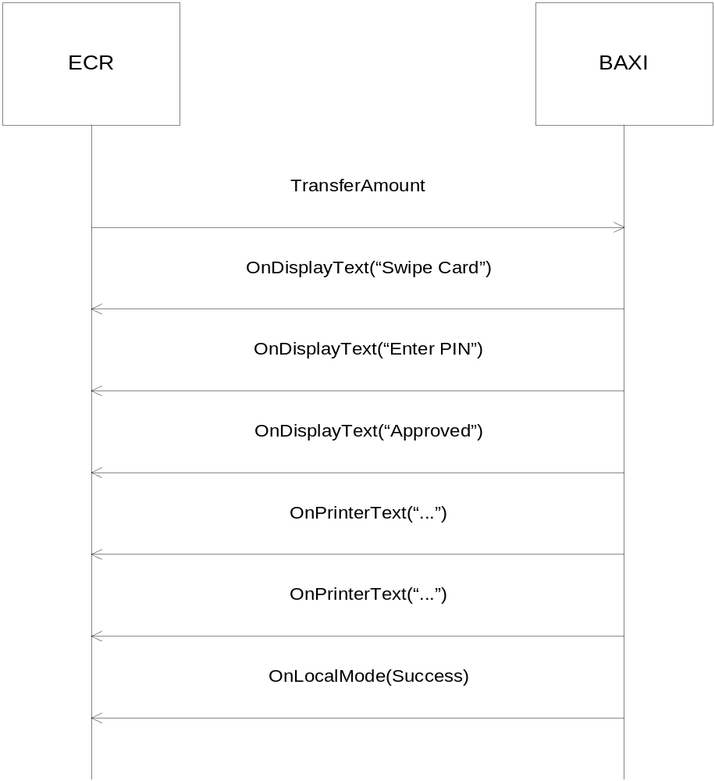

- Normal purchase transaction request (10.00 kr) with VAT (3 kr):
TransferAmountArgs a = new TransferAmountArgs();
a.OperID = “0000”;
a.Type1 = 0x30;
a.Amount1 = 1000;
a.Type2 = 0x30;
a.Amount2 = 0;
a.Type3 = 0x32;
a.Amount3 = 300;
a.HostData = “”;
a.ArticleDetails = “”;
a.PaymentConditionCode = “”;
a.AuthCode = “”;
int result = Baxi.TransferAmount(a);
The amount3 field can be used to send the VAT information for a particular transaction.

SEQUENCE DIAGRAM:

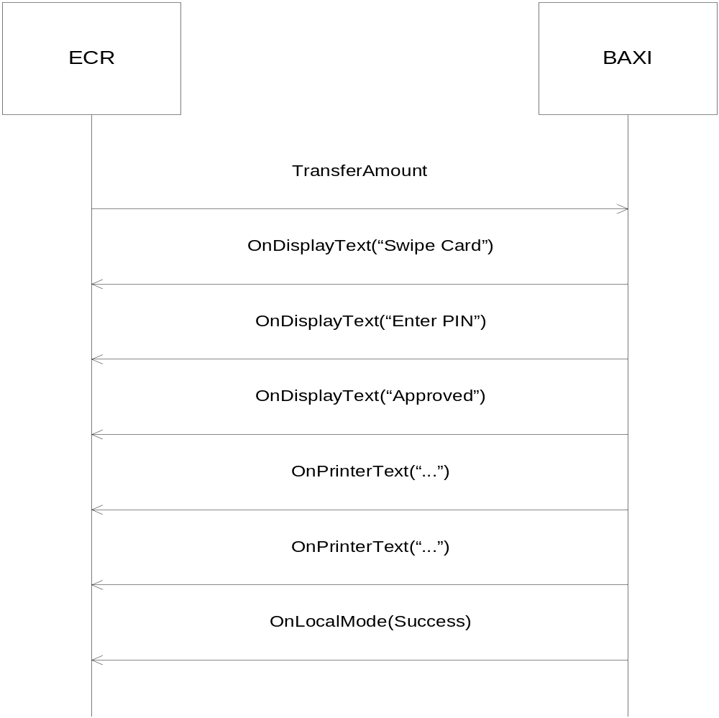

- Normal purchase transaction request (10.00 kr) with loyalty info (“abcdefg”):
TransferAmountArgs a = new TransferAmountArgs();
a.OperID = “0000”;
a.Type1 = 0x30;
a.Amount1 = 1000;
a.Type2 = 0x30;
a.Amount2 = 0;
a.Type3 = 0x30;
a.Amount3 = 0;
a.HostData = “abcdefg”;
a.ArticleDetails = “”;
a.PaymentConditionCode = “”;
a.AuthCode = “”;
int result = Baxi.TransferAmount(a);
The Host data field is used to send extra information to the host. One example could be the loyalty card info that can be send through this field. This sis merchant dependent.

SEQUENCE DIAGRAM:

- Normal purchase transaction request (10.00 kr) for multiterminal setup:
TransferAmountArgs a = new TransferAmountArgs();
a.OperID = “0001”;
a.Type1 = 0x30;
a.Amount1 = 1000;
a.Type2 = 0x30;
a.Amount2 = 0;
a.Type3 = 0x30;
a.Amount3 = 0;
a.HostData = “”;
a.ArticleDetails = “”;
a.PaymentConditionCode = “”;
a.AuthCode = “”;
int result = Baxi.TransferAmount(a);
Here a single master terminal is used to select slave terminals connected to it. They are distinguished by the operator ID’s and can be selected from the master terminal accordingly for transactions.

SEQUENCE DIAGRAM:

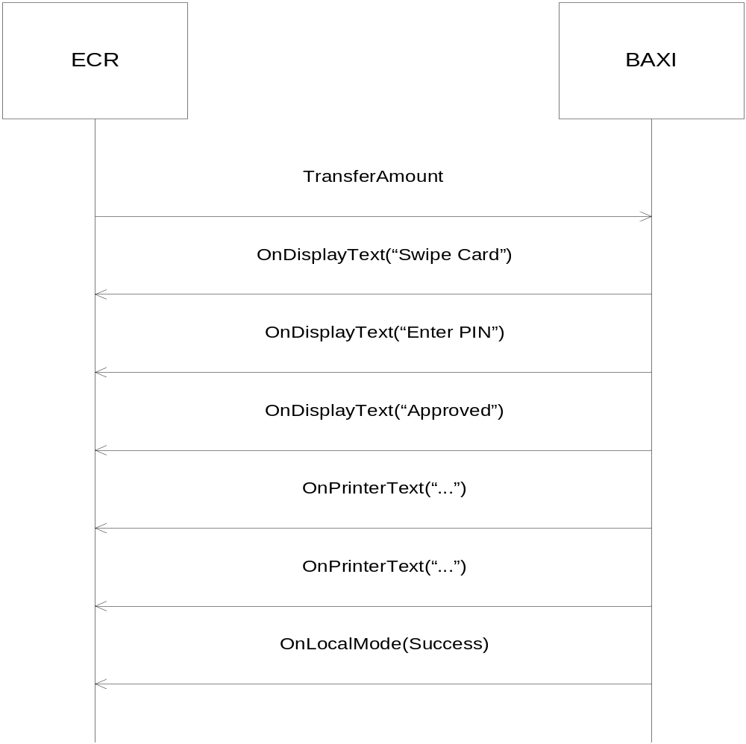

- Normal purchase transaction request (10.00 kr) with payment condition code “2”:
TransferAmountArgs a = new TransferAmountArgs();
a.OperID = “0000”;
a.Type1 = 0x30;
a.Amount1 = 1000;
a.Type2 = 0x30;
a.Amount2 = 0;
a.Type3 = 0x30;
a.Amount3 = 0;
a.HostData = “”;
a.ArticleDetails = “”;
a.PaymentConditionCode = “2”;
a.AuthCode = “”;
int result = Baxi.TransferAmount(a);
The Payment condition code field is used to specify a particular purchase scheme the merchant might have for a particular purchase. For eg. A pay by instalment scheme.

SEQUENCE DIAGRAM:

Return of goods
Used to refund the customer for goods returned due to defect.
TransferAmountArgs a = new TransferAmountArgs();
a.OperID = “0000”;
a.Type1 = 0x31;
a.Amount1 = 1000;
a.Type2 = 0x30;
a.Amount2 = 0;
a.Type3 = 0x30;
a.Amount3 = 0;
a.HostData = “”;
a.ArticleDetails = “”;
a.PaymentConditionCode = “”;
a.AuthCode = “”;
int result = Baxi.TransferAmount(a);

SEQUENCE DIAGRAM:

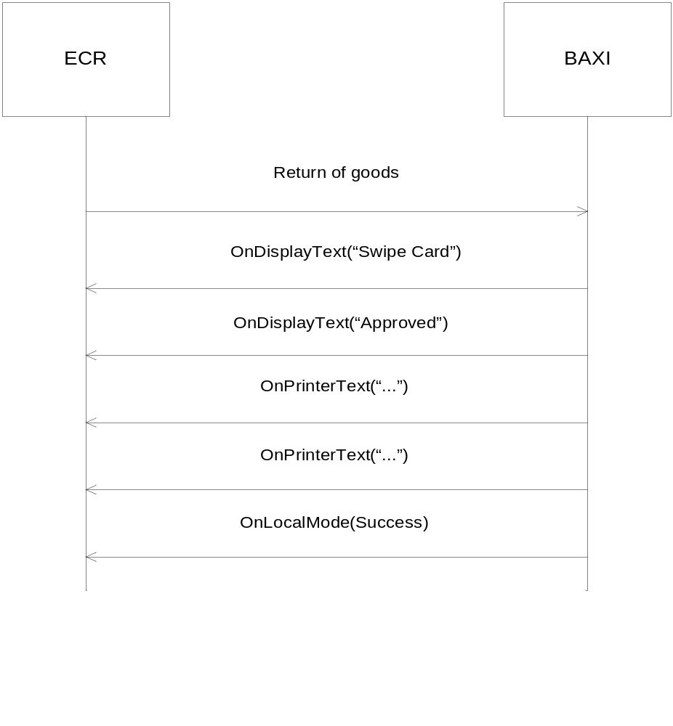

Reversal
Reversal of the last transaction (10 kr).
TransferAmountArgs a = new TransferAmountArgs();
a.OperID = “0000”;
a.Type1 = 0x32;
a.Amount1 = 1000;
a.Type2 = 0x30;
a.Amount2 = 0;
a.Type3 = 0x30;
a.Amount3 = 0;
a.HostData = “”;
a.ArticleDetails = “”;
a.PaymentConditionCode = “”;
a.AuthCode = “”;
int result = Baxi.TransferAmount(a);

SEQUENCE DIAGRAM:

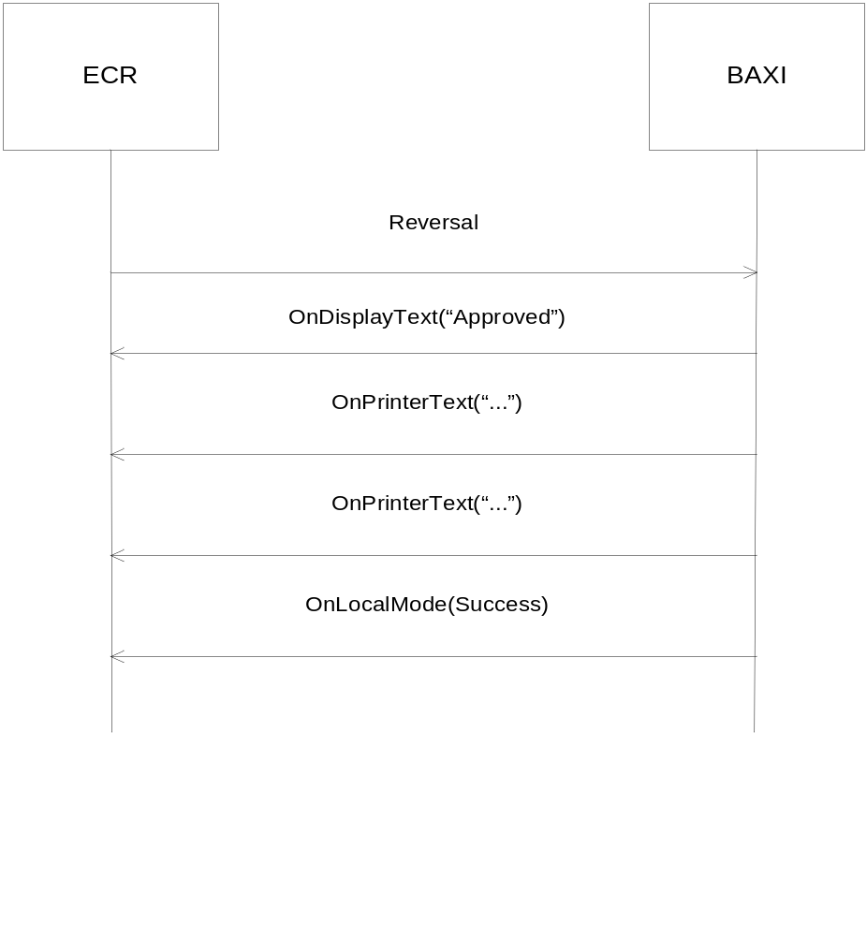

Purchase with Cashback

Purchase transaction request (10.00 kr) with cash back (2 kr):

TransferAmountArgs a = new TransferAmountArgs();
a.OperID = “0000”;
a.Type1 = 0x33;
a.Amount1 = 1200;
a.Type2 = 0x30;
a.Amount2 = 1000;
a.Type3 = 0x30;
a.Amount3 = 0;
a.HostData = “”;
a.ArticleDetails = “”;
a.PaymentConditionCode = “”;
a.AuthCode = “”;
int result = Baxi.TransferAmount(a);

SEQUENCE DIAGRAM:

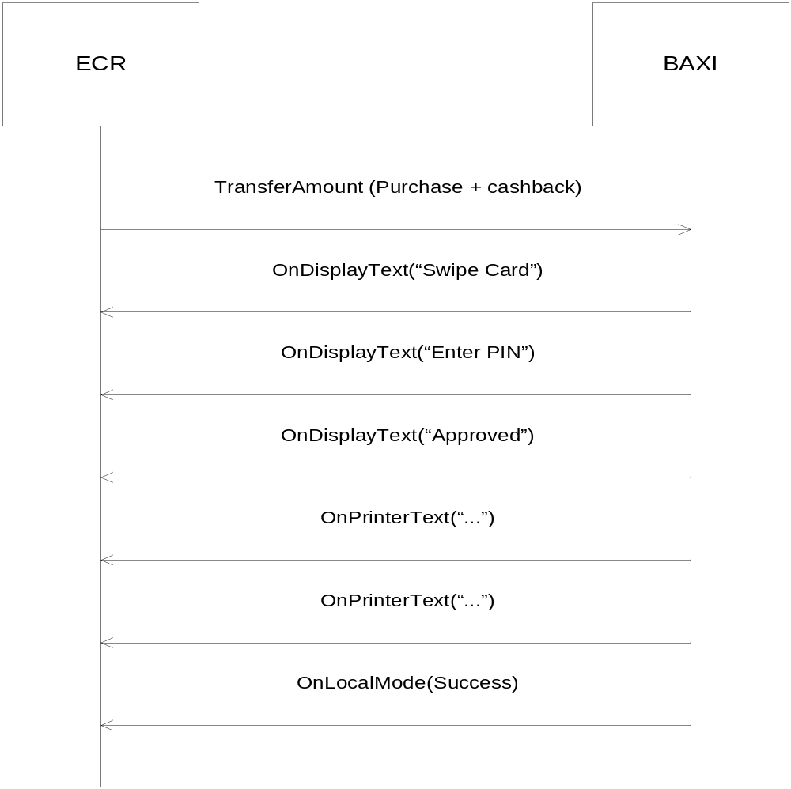

Balance inquiry
Gives the balance amount for purchase on the card.

TransferAmountArgs a = new TransferAmountArgs();
a.OperID = “0000”;
a.Type1 = 0x36;
a.Amount1 = 0;
a.Type2 = 0x30;
a.Amount2 = 0;
a.Type3 = 0x30;
a.Amount3 = 0;
a.HostData = “”;
a.ArticleDetails = “”;
a.PaymentConditionCode = “”;
a.AuthCode = “”;
int result = Baxi.TransferAmount(a);

SEQUENCE DIAGRAM:

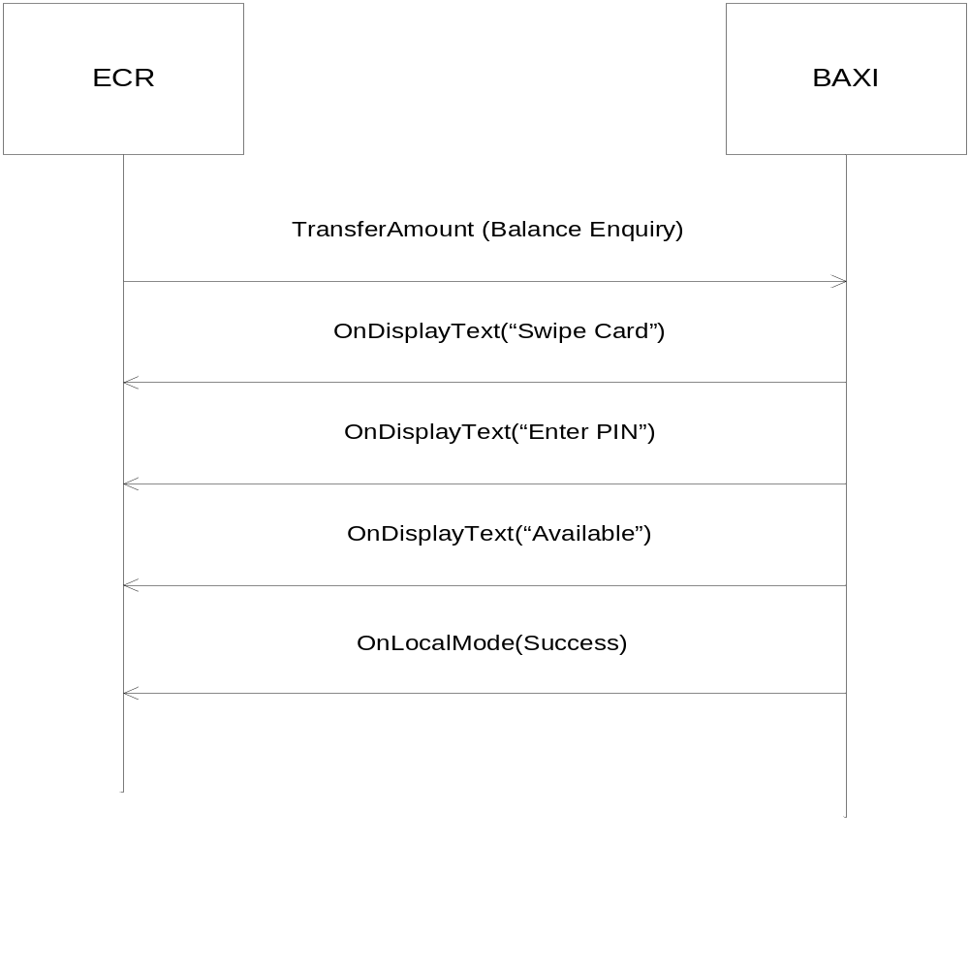

Deposit
Can be used for example to deposit money on gift cards.

TransferAmountArgs a = new TransferAmountArgs();
a.OperID = “0000”;
a.Type1 = 0x38;
a.Amount1 = 1000;
a.Type2 = 0x30;
a.Amount2 = 0;
a.Type3 = 0x30;
a.Amount3 = 0;
a.HostData = “”;
a.ArticleDetails = “”;
a.PaymentConditionCode = “”;
a.AuthCode = “”;
int result = Baxi.TransferAmount(a);

SEQUENCE DIAGRAM:

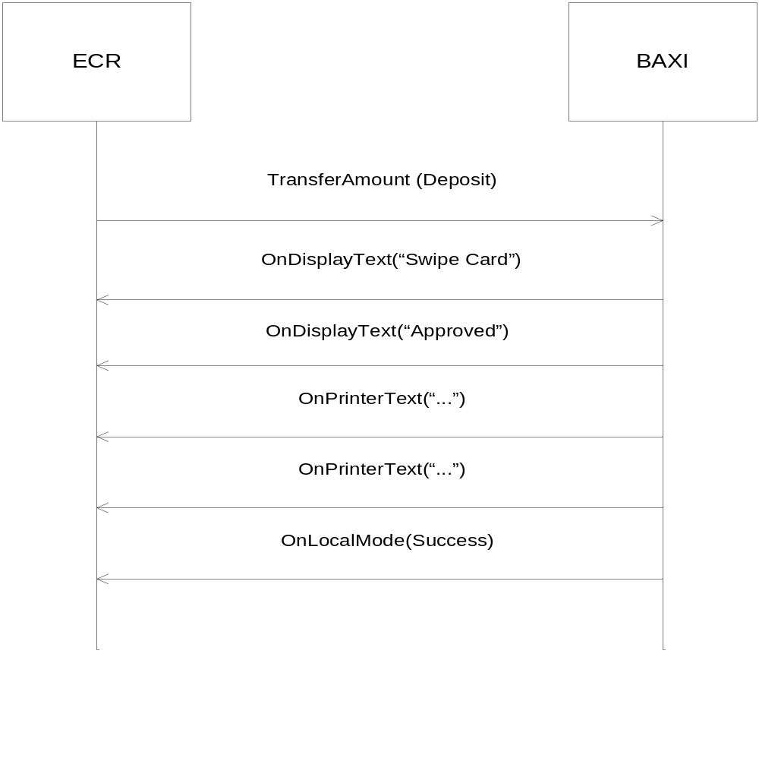

Cash withdrawal
Can be used to withdraw a certain amount from the card as requested by the customer.

TransferAmountArgs a = new TransferAmountArgs();
a.OperID = “0000”;
a.Type1 = 0x39;
a.Amount1 = 1000;
a.Type2 = 0x30;
a.Amount2 = 0;
a.Type3 = 0x30;
a.Amount3 = 0;
a.HostData = “”;
a.ArticleDetails = “”;
a.PaymentConditionCode = “”;
a.AuthCode = “”;
int result = Baxi.TransferAmount(a);

SEQUENCE DIAGRAM:

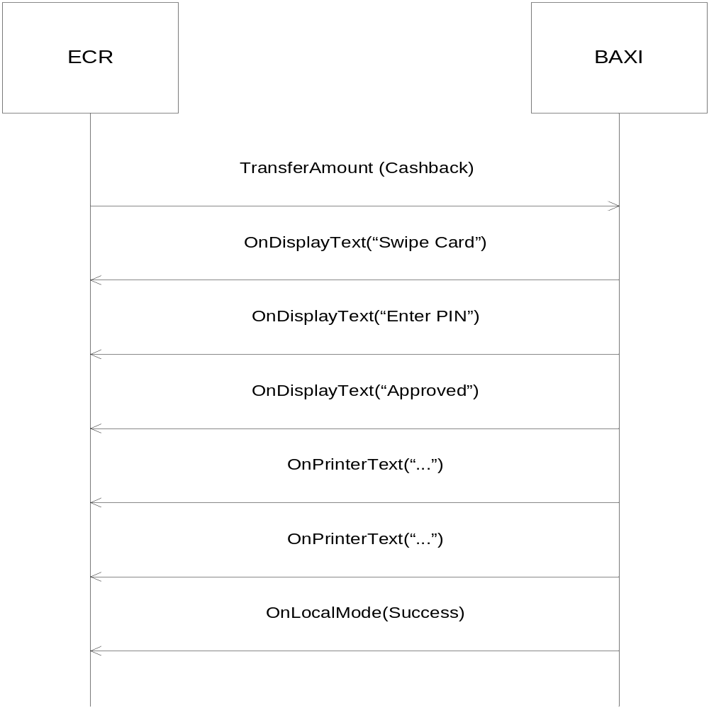

Force Offline

Force an offline purchase of amount 1000 with authcode of ‘ABC’.

TransferAmountArgs a = new TransferAmountArgs();
a.OperID = “0000”;
a.Type1 = 0x40;
a.Amount1 = 1000;
a.Type2 = 0x30;
a.Amount2 = 0;
a.Type3 = 0x30;
a.Amount3 = 0;
a.HostData = “”;
a.ArticleDetails = “”;
a.PaymentConditionCode = “”;
a.AuthCode = “ABC”;
int result = Baxi.TransferAmount(a);

SEQUENCE DIAGRAM:

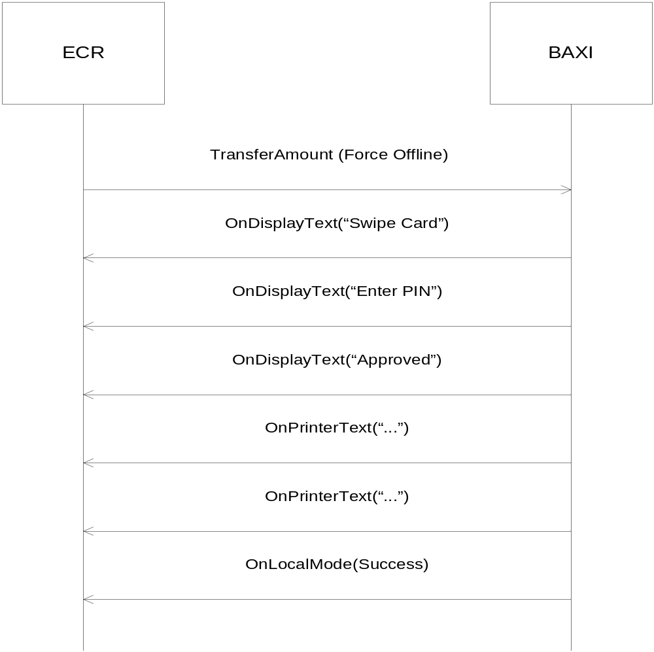

Pre-Authorisation
- Done in at least two parts where the initial part Authorises an estimated amount, in this case Amount1=1000.

TransferAmountArgs a = new TransferAmountArgs();
a.OperID = “0000”;
a.Type1 = 0x34;
a.Amount1 = 1000;
a.Type2 = 0x30;
a.Amount2 = 0;
a.Type3 = 0x30;
a.Amount3 = 0;
a.HostData = “”;
a.ArticleDetails = “”;
a.PaymentConditionCode = “”;
a.AuthCode = “”;
a.OptionalData = “”;
int result = Baxi.TransferAmount(a);

In the OnLocalMode response keep what is sent in args.getOptionalData():

{"od":{"ver":"1.01","preauth":{"ver":"1.0","auth":{"ver":"1.0","token":{"ver":"1.0","t":"WZyq1XadTyso8AnpJdCT1GPKWUw=","e":"140903"}},"data":{"ver":"1.0","id":4,"tpan":"521358******2083","ref":"591504 125853","TCC":"D@1","resp":"00"},"receipt":{"ver":"1.0","cdt":{"ver":"1.0","prnstr":["MASTERCARD ","************2083"]}}}}}

ECR

BAXI

TransferAmount(Authorisation)

OnDisplayText(“Swipe Card”)

OnDisplayText(“Enter PIN”)

OnDisplayText(“Approved”)

OnPrintText(“. . .”)

OnPrintText(“. . .”)

OnLocalmode(Success + OptionalDataToken)

- Use the OptionalData token from the original Authorisation to append any additional estimated Amount – in this example Amount1=500. This doesn’t require the card of the Customer. This is an optional step that is not needed to finish the transaction. Escape any quotation marks in the middle of the OptionalData String.

TransferAmountArgs a = new TransferAmountArgs();
a.OperID = “0000”;
a.Type1 = 0x41;
a.Amount1 = 500;
a.Type2 = 0x30;
a.Amount2 = 0;
a.Type3 = 0x30;
a.Amount3 = 0;
a.HostData = “”;
a.ArticleDetails = “”;
a.PaymentConditionCode = “”;
a.AuthCode = “”;
a.OptionalData = "{\"od\":{\"ver\":\"1.01\",\"preauth\":{\"ver\":\"1.0\",\"auth\":{\"ver\":\"1.0\",\"token\":{\"ver\":\"1.0\",\"t\":\"WZyq1XadTyso8AnpJdCT1GPKWUw=\",\"e\":\"140903\"}},\"data\":{\"ver\":\"1.0\",\"id\":4,\"tpan\":\"521358******2083\",\"ref\":\"591504 125853\",\"TCC\":\"D@1\",\"resp\":\"00\"},\"receipt\":{\"ver\":\"1.0\",\"cdt\":{\"ver\":\"1.0\",\"prnstr\":[\"MASTERCARD \",\"************2083\"]}}}}}";
int result = Baxi.TransferAmount(a);

ECR

BAXI

TransferAmount(Incremental Pre Authorisation)

OnDisplayText(“Please Wait”)

OnDisplayText(“Approved”)

OnPrintText(“. . .”)

OnPrintText(“. . .”)

OnLocalmode(Success)

- The final part is the Sale Completion. Please note that the final Amount may differ somewhat from the initially estimated Authorisation, in this case Amount1=1600. This doesn’t require the Customer’s card.

TransferAmountArgs a = new TransferAmountArgs();
a.OperID = “0000”;
a.Type1 = 0x43;
a.Amount1 = 1600;
a.Type2 = 0x30;
a.Amount2 = 0;
a.Type3 = 0x30;
a.Amount3 = 0;
a.HostData = “”;
a.ArticleDetails = “”;
a.PaymentConditionCode = “”;
a.AuthCode = “”;
a.OptionalData = "{\"od\":{\"ver\":\"1.01\",\"preauth\":{\"ver\":\"1.0\",\"auth\":{\"ver\":\"1.0\",\"token\":{\"ver\":\"1.0\",\"t\":\"WZyq1XadTyso8AnpJdCT1GPKWUw=\",\"e\":\"140903\"}},\"data\":{\"ver\":\"1.0\",\"id\":4,\"tpan\":\"521358******2083\",\"ref\":\"591504 125853\",\"TCC\":\"D@1\",\"resp\":\"00\"},\"receipt\":{\"ver\":\"1.0\",\"cdt\":{\"ver\":\"1.0\",\"prnstr\":[\"MASTERCARD \",\"************2083\"]}}}}}";
int result = Baxi.TransferAmount(a);

ECR

BAXI

TransferAmount(Sale Completion Pre Authorisation)

OnDisplayText(“Approved”)

OnPrintText(“. . .”)

OnPrintText(“. . .”)

OnLocalmode(Success)

TopUp
These are typically used to load a mobile phone with more call time. See ref 1 for details. The EAN number of the transaction is specified in the articleDetails parameter.
Buy a NetCom 150 TopUp code:
TransferAmountArgs a = new TransferAmountArgs();
a.OperID = “0000”;
a.Type1 = 0x3B;
a.Amount1 = 1000;
a.Type2 = 0x30;
a.Amount2 = 0;
a.Type3 = 0x30;
a.Amount3 = 0;
a.HostData = “”;
a.ArticleDetails = “07021940002810” + "\x1e"; // record separator
a.PaymentConditionCode = “”;
a.AuthCode = “”;
int result = Baxi.TransferAmount(a);

SEQUENCE DIAGRAM:

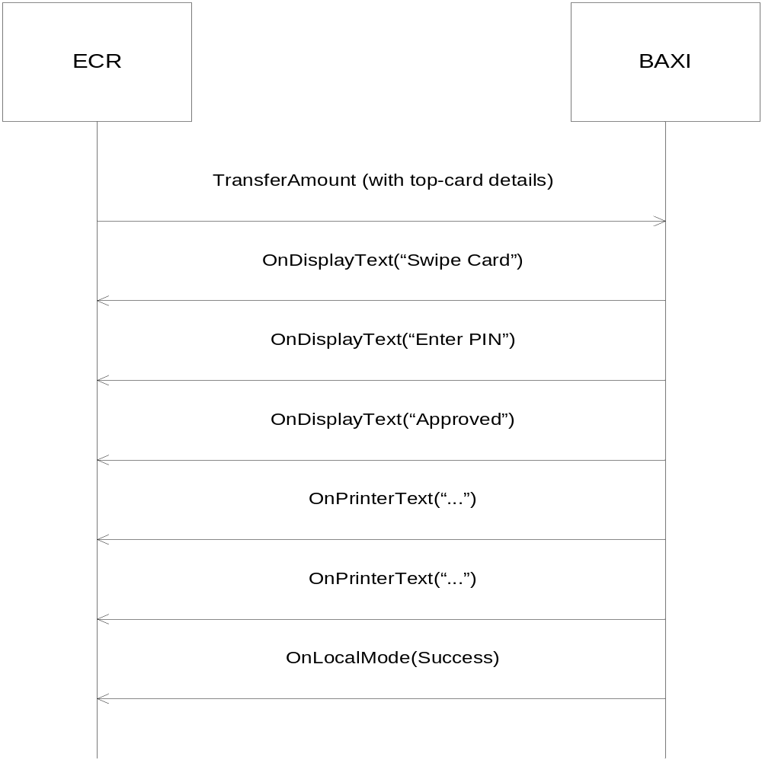
Receive the topup code from the OnTLDReceived event, TLDReceivedArgs contents:

RS = “\x1e”, US = “\x1f”

TldType : “INFO”
TldData: “4005” + US + “00066” + US +
“07021940002810” + US + “00000000833” + US + “7146417457411” + US + “0000004266-94-79” + US + “0015000” + RS

Gift Card
Gift card is implemented as a two transaction solution.
- First do a normal purchase with the customer card.
Normal purchase transaction request (10.00 kr):

TransferAmountArgs a = new TransferAmountArgs();
a.OperID = “0000”;
a.Type1 = 0x30;
a.Amount1 = 1000;
a.Type2 = 0x30;
a.Amount2 = 0;
a.Type3 = 0x30;
a.Amount3 = 0;
a.HostData = “”;
a.ArticleDetails = “”;
a.PaymentConditionCode = “”;
a.AuthCode = “”;
int result = Baxi.TransferAmount(a);

SEQUENCE DIAGRAM:

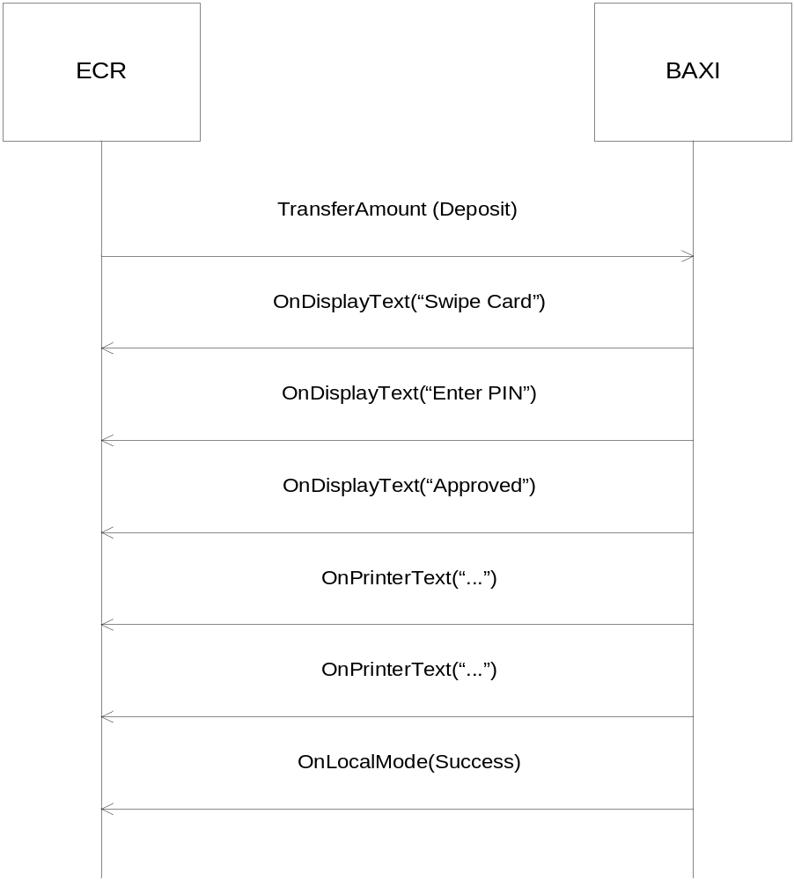

- Do a deposit with the same amount as the customer purchase.
TransferAmountArgs a = new TransferAmountArgs();
a.OperID = “0000”;
a.Type1 = 0x38;
a.Amount1 = 1000;
a.Type2 = 0x30;
a.Amount2 = 0;
a.Type3 = 0x30;
a.Amount3 = 0;
a.HostData = “”;
a.ArticleDetails = “”;
a.PaymentConditionCode = “”;
a.AuthCode = “”;
int result = Baxi.TransferAmount(a);

- Send the track 2 content of the giftcard with the TransferCardData() function. The track type can be 32 for card initiated transfer and 40 for manual entry card data. The track data is comprised of track 2(“9578351002001375176”) , date(“YYMM” – “1912”) and cvc(“501”)

TransferCardDataArgs a = new TransferCardDataArgs();
a.TrackType = 0x32;
a.TrackData = “9578351002001375176=1912501”;

int result = Baxi.TransferCardData(a);

SEQUENCE DIAGRAM OF 2 & 3:

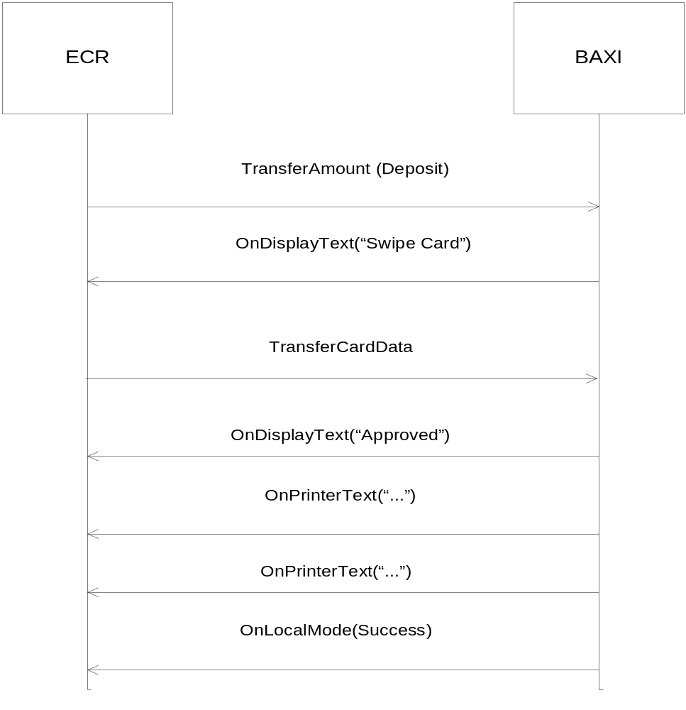

The terminal will finish the deposit on the gift card.

Group ID
Group ID is a function used to separate cards within the same range based on values returned from the card. This functionality is currently only supported by NETS cards. This functionality is used in situations where you want to give different prices to customers with the same type of prepaid NETS cards, typically in canteens used by more than one company, where employees from the different companies gets different prices.

To retrieve the Group ID use the following sequence:

Call the function SendTLD() specifying a Group ID request:

SendTldArgs a = new SendTldArgs();
a.TldType = “REQ”;
a.TldField = “3000”;
Baxi.SendTLD(a);

Get the group ID from the OnTLDReceived event, TLDReceivedArgs contents:

TldType : “RESP”
TldData : “3000” + US + “0005” + US + “12345” + RS

TIP
To be able to use tip, the service has to be enabled for the terminal. This can be ordered from your dealer.
If the amount received in the amount field in the Local Mode message from the terminal is larger than the amount sent to the terminal in the Transfer Amount message, the difference should be treated as tip.

Send a track 2 card swipe to the terminal:
TransferCardDataArgs a = new TransferCardDataArg();
a.TrackType = 0x32;
a.TrackData = “9571921000000000236”;
Baxi.TransferCardData(a);

Set terminal language (Only on Unicapt Terminals)
Call the function SendTLD() specifying setting terminal language.

Ex English:

SendTldArgs a = new SendTldArgs();
a.TldType = “CMD”;
a.TldField = “1014” + US + “0002” + US + “en” + RS;
Baxi.SendTLD(a);

Receive a card inserted status event

The terminal can be set to send events when a card is inserted or removed. Read the status in the OnTLDReceived function.

Ex card inserted:

TldType : “STATUS”
TldData : “1013” + US + ”0001” + US + ”1” + RS

Check host connection (Only on Unicapt terminals)
Call the function SendTLD() specifying a request for host connection status:

SendTldArgs a = new SendTldArgs();
a.TldType = “REQ”;
a.TldField = “1012”;
Baxi.SendTLD(a);

Read the host connect status in the OnTLDReceived response, TLDReceivedArgs contents:

Ex connected to host:

TldType : “RESP”
TldData : “1012” + US + ”0001” + US + ”0” + RS

“Get Customer Info”
WARNING: This functionality is only supported on terminal versions 07.1X and higher. It must be turned off for older releases.

The generic TLD format is defined in [1].

The ECR invokes the Get Customer Info by sending a TLD request with the following tags in the given order:

“2000” + US + ”0003” + US + ”001” + RS +
“2002” + US + ”0003” + US + ”001” + RS +
“2001” + US + ”0000” + US + RS

The tags must be in the order above for the request to work.

The ITU typically returns the customer information from the above request in the following manner:

“2000” + US + “0003” + US + “001” + RS +
“2002” + US + “0003” + US + “001” + RS +
“2001” + US + “0032” + US + “00987654 “ + RS +
“2003” + US + “0002” + US + “00” + RS

When the ITU sends a TLD Status “Card inserted with Issuer ID” message, it typically contains the following (for a BankAxept card, issuer 30):

“1013” + US + “0001” + US + “1” + RS +
“3002” + US + “0010” + US + “0000000030” + RS

To receive the issuer ID tag in the card status message, the parameter for sending issuer ID with card status must be enabled in the ITU.

There are 2 normal use cases for the Customer Info functionality.
- The ECR always initiates a GetCustomerInfo, before the purchase. (Automatic retrieval of Customer Info is turned on in the ITU). It is then the ITU which decides if there should be a request to the host, based on Issuer ID and terminal configuration.
- The ECR receives “card inserted with issuer ID” from the ITU and based on issuer ID elects to initiate a customer info request or not.

Below are these 2 use cases described in detail. The data within the messages will typically be as described above.

ECR initiates GetCustomerInfo.
The parameter for sending card status messages should be disabled for this scenario. This is because it is not needed by the ECR and it can also increase the risk of collisions and retransmissions.
Automatic customer info retrieval is enabled.

Sequence:
- The ECR will always initiate a transaction with a GetCustomerInfo request to the ITU through a TLD Request.
- The terminal goes into Bank Mode.
- The terminal will either ask for a card, or start processing if a card is already inserted or swiped.
- The terminal will return the Customer Info to ECR through a TLD Response and remains in bank mode. It is awaiting a TransferAmount transaction.
- The ECR processes the Customer Info and initiates a transaction. It is also possible to send an Admin Cancel (or Admin finish, see below) at this stage, if the ECR is not interested in any additional actions other than the customer info data.
- The ITU will complete any transaction or cancellation with a Local Mode message.

ECR reacts to Card Inserted
Automatic customer info retrieval is disabled. “Card status messages with Issuer ID” is enabled in the ITU.

Sequence:
- The ITU will send a TLD Status message with “Card inserted and Issuer ID” to the ECR, when the customer inserts or swipes a card in the ITU.
- ECR processes the Issuer ID and decides if it should send a Get Customer Info request or not.
- ECR sends a Customer Info TLD Request.
- The ITU goes into Bank Mode.
- The ITU requests the customer info from the host and sends a TLD Response with Customer Info to the ECR.
- The ITU then awaits further action from the ECR and remains in Bank Mode.
- The ECR processes the Customer Info and normally sends a TransferAmount message to the ITU.
- The ITU will handle the transaction like normal and complete it with a Local Mode message.

“Get Customer Info” with Admin Finish.
For the “Get Customer Info” dialogues or any other TLD request dialogue, the terminal can remain in Bank Mode and expect a final transaction to take place. There are occurrences where such a transaction will not take place and the ECR wishes to force the Terminal out of bank mode and back to idle. This effectively completes the operation/dialogue and makes the terminal ready for a new operation/dialogue.
This has been achieved with Admin Cancel in the past. This has the unwanted behaviour of the terminal aborting the transaction in full, including display texts and showing “Cancelled by operator” in its display etc.
The Admin Finish command is an alternative to Admin Cancel in these cases, where it is better for the terminal to silently abort and revert to Local Mode and showing an idle screen.
For Admin Finish:
AdministrationArgs a = new AdministrationArgs();
a.OperID = “1234”;
a.AdmCode = 0x313B;

int result = Baxi. administration(a);

Investigating results of last financial transaction.
If an error occurs in the middle of a transaction, JBAXI will return an error and a local mode result of “Unknown”. If such an error or other errors make the result of a transaction unavailable or incomplete, one can use the Administration functions “Print Latest Financial Transaction Receipt” and “Send Latest Financial Transaction Result” to fetch the result from the ITU. This is a complement to the manual routines to provide an integrated solution for this problem for ECR vendors.
Let us assume that a transaction is unknown. To retrieve all necessary information, the ECR will have to perform the following:
int result = Baxi.Administration(new AdministrationArgs(0x313C, “0000”));

This results in a PrintText event, which will contain a copy receipt of the latest financial transaction result. This is identical to entering the ITU menu and manually print out the copy receipt.
After the Local mode is received (administration is done), the ECR can send the next administration message to get the Latest Financial transaction result, which contains the Local mode data from the last financial transaction.
int result = Baxi.Administration(new AdministrationArgs(0x313D, “0000”));

This results in a LastFinancialTransactionResult event, which contains the local mode identical data from the last financial transaction. The administration operation is then completed with a local mode message.

JSON replacing TLD

CardInfo RequestAllTags(3999) using sendJson
As described in chapter 6 sendJson() replaces sendTld(). ECR can query Baxi to retrieve any information available about the current card. If a card is not present then it will be requested by the terminal after this call.

sendTld
As reference this is how it is used with sendTld():
SendTldArgs a = new SendTldArgs();
a.TldType = “REQ”;
a.TldField = “3999”;
Baxi.SendTLD(a);
OnTLDReceived returns the following where US is replaced by “ “ and RS by linefeed in the example:
3000 0000
3001 0016 <six digits>******<four digits>
3002 0001 3
3003 0003 752
3004 0001 Y
3005 0001 Y
3009 0000
3011 0003 D__
3012 0008 STANDARD
3013 0000
3014 0000

sendJson
This is how it is done using sendJson() to send the same thing using the following JSON:
{
"cardinfo": {
"ver": "1.00",
"alltags": "?"
}
}
Code:
SendJsonArgs args = new SendJsonArgs(
"{\n" +
" \"cardinfo\": {\n" +
" \"ver\": \"1.00\",\n" +
" \"alltags\": \"?\"\n" +
" }\n" +
"}");
baxi.sendJson(args);

OnJsonReceived returns the following:
{
"cardinfo": {
"ver": "1.00",
"iccgrpid": "",
"pan": "<six digits>******<four digits>",
"issid": "3",
"countrycode": "752",
"restrictions": "Y",
"fee": "Y",
"track2": "",
"tcc": "D__",
"bankagent": "STANDARD",
"track3": "",
"loyaltyinfo": ""
}
}

JSON and Multiterminal
A single terminal can be configured with different TerminalId and therefore allow for separated configuration. To use sendJson with Multiterminal add the optional tag “o” and “merch” with the six digit merchant number to the JSON call. The Merchant Number is the first six digits of the TerminalId. This is also seen on the receipt as TERM: <6 digit MerchantNr><2 digit id>-<6 digit MerchantNr> i.e. TERM: 11223344-112233. In this example the Merchant Number is 112233 and the TerminalId 11223344. For single TerminalId terminals this optional “merch” tag is ignored.
"o": {
"ver": "1.00",
"merch": 112233
}

Used with CardInfo RequestAllTags the JSON call will look like this:
{
"cardinfo": {
"ver": "1.00",
"alltags": "?"
},
"o": {
"ver": "1.00",
"merch": 112233
}
}

JSON and VAS (Value Added Services)
Any number of Value Added Services can be used through the transparent Baxi JSON interface towards the Host. JSON is sent using sendJson() in Baxi and the response comes back in OnJsonReceived in the form of another JSON. Specific VAS will not be detailed here as this guide will remain service agnostic.

Best practice implementation of security in ECR

These are recommendations concerning some of the security functions offered with JBaxi and NETS terminals. Recommended practice is to implement all functions with high security.

These recommendations are based on experienced skimming practices which mainly have been:

- Skimming equipment is mounted on the terminal when the shop is closed.
- The shops terminal is replaced with a terminal with skimming equipment mounted.

Powercyclecheck is designed to counter scenario 1, while the other functions are designed to counter scenario 2.

Function | Low security | Medium security | High security
VendorInfo extendended.  Data reported by ECR to terminal. Readable by NETS. | Identification of pos application supplier in the vendorinfoextended string | Identification of pos application supplier and Identification of sit e in the vendorinfoextended string | Identification of pos application supplier and unique Identification of POS in the vendorinfoextended string
Powercyclecheck  Checks when the terminal has been tuned on and off. | Turned off | Turned on | Action demanded from the POS operator on the OnDisplayText generated
Tidcheck  Checks if the TID (TermianlD) of the terminal has changed. | Turned off | Turned on | Turned off in Baxi.ini, but implemented tid check in the POS application with action required from the pos operator on tid change, Preferable with operator authentication.
Serial number check  Checks if the physical serialnumber of the terminal has changed. | No serial number check. | Implement serial number check in the POS application with action required from the pos operator on serial number. | Implement serial number check in the POS application with action required from the pos operator on serial number change with operator authentication.

ECR Display Text ID’s
This lists the different Display Text strings with unique ID that an ITU (Integrated Terminal Unit) can send to an ECR. ECR can use the unique text id’s to synchronize the display text on the application if required.
The source for the ECR display text’s Could be Terminal, Host, JBAXI or Card.
Available Source IDs are:
1 = Terminal has generated the Display Text ID
2 = Host has generated the Display Text ID
3 = Baxi has generated the Display Text ID
4 = Card has generated the Display Text ID.
The display text Id’s are listed below based on the different source types.

Source : Terminal
TEXT ID | TEXT | Source | Comments
1 | PIN + OK | Terminal
2 | Customer Approved\rAmount | Terminal
3 | Choose debit\ Credit | Terminal
1001 | REMOVE CARD | Terminal
1002 | INSERT CARD | Terminal | For attended terminals
1003 | INSERT CARD | Terminal | For unattended terminal
1004 | Purchase | Terminal
1005 | Technical | Terminal
1006 | Waiting | Terminal
1007 | TimeOut | Terminal
1008 | Error, Try again | Terminal
1009 | Wrong PIN, Last PIN try | Terminal
1010 | Unknown Card | Terminal
1011 | Awaiting card | Terminal

Source: Host
TEXT ID | TEXT | Source | Comments
Response code from host | Dynamic text from host | Host | The unique text id for display texts from host is same as the response code.

Source: Baxi
TEXT ID | TEXT | Source | Comments
None defined |  | BAXI

Source: Card
TEXT ID | TEXT | Source | Comments
0 | Application name | Card | Application name depends upon card issuer
1008 | Error, Try again | Card

Known issue with linux USB
"UTSKRIFT PAGAR" is displayed on ECR and Terminal but print stored in the terminal is not printed on ECR.

Scenario:
- Open Jbaxi
- Perform reconciliation
- Close Jbaxi
- Perform offline transaction with bankaxept card, VISA and MasterCard to store the EMV offline transactions (EOT’s) and some print on the terminal
- Open Jbaxi – local mode success is received
- Send Admin-> Klar

Expected Result:
The prints stored on the terminal must be printed on the ECR.

Actual Result:
Terminal and ECR displays "UTSKRIFT PAGAR", but there is no print on the ECR printer. LM is rejected.

Analysis:
Reproducible with ingenico SDK 9.2 and above on the terminal. (Only on linux)
This issue occurs only if Jbaxi is closed after reconciliation followed by EOT’s. In case of connection break (Ethernet going down) and generation of EOT’s, the prints are sent successfully to the ECR after it goes online.
Recovery:
- Close baxi.
- Unplug the USB cable.
- Plug USB cable.
- Open baxi.
- It starts working fine after this step.

Appendices

Appendix A – Status codes

Error codes

Error code | Description
2011 | Error when sending message
6003 | Busy
6006 | Baxi locked
7001 | Unknown Error
7005 | Open rejected
7007 | Obsolete terminal version
7008 | No host contact.
7009 | No response from terminal
7010 | Create log directory fail
7011 | Open IO fail
7012 | Unexpected frame
7013 | Close rejected
7014 | No Response from Controller
7015 | Unknown terminal frame
2111 | Socket General Error
2112 | Socket Timeout
2113 | Socket Socket Error
2114 | Socket Message Length Error
2115 | Socket Sending of Message Failed
2116 | Socket Connection Error

Method reject codes

Method Reject code | Description
 | General cases
7100 | Processing previous command
7101 | Unable to process
7102 | Already Open
7103 | Not Active
7104 | Terminal busy, administration
 | Property bad values
7401 | Log file prefix
7402 | Log file path
7403 | Host IP address
7404 | Vendor info extended
7405 | Trace level
7406 | Baud rate
7407 | COM port
7408 | Host port
7409 | Indicate EOT transactions
7410 | Cutter support
7411 | Printer width
7412 | Display width
7413 | Power cycle check
7414 | TID supervision
7415 | Auto get customer info
7416 | DeviceString
7420 | Terminal ready
7421 | UseDisplayTextID
7422 | UseExtendedLocalMode
7426 | DoNotSplitDisplayText
 | Function argument bad values
7501 | Only track 2 support
7502 | Invalid track length
7503 | Transfer amount invalid type
7504 | Transfer amount data too long
7505 | Transfer amount article details too long
7506 | Invalid operator ID
7507 | Invalid administration code
7508 | TLD unknown type
7509 | TLD bad field value
7510 | TLD could not build
7511 | Transfer amount PCC too long
7512 | Transfer amount PCC not alphanumeric
7513 | Transfer amount AuthCode too long.
7514 | Transfer amount AuthCode not alphanumeric.
7515 | JSON Bad field value
7516 | Transfer amount Optional Data too long.
 | EF Cases
7998 | EF Functionality is busy
7999 | EF Functionality is not activated

Appendix B – Sequence diagrams

Initialisation
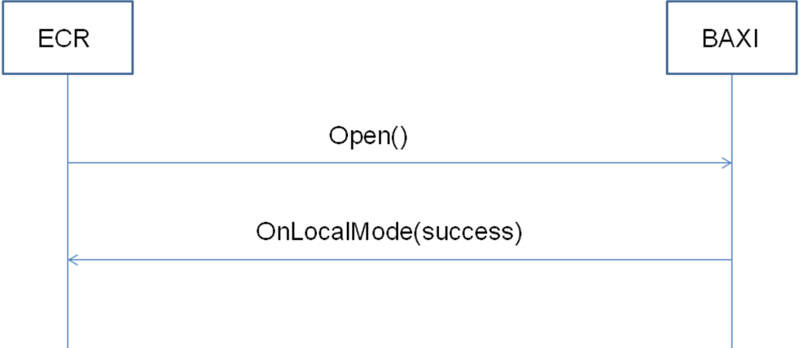

Successful purchase
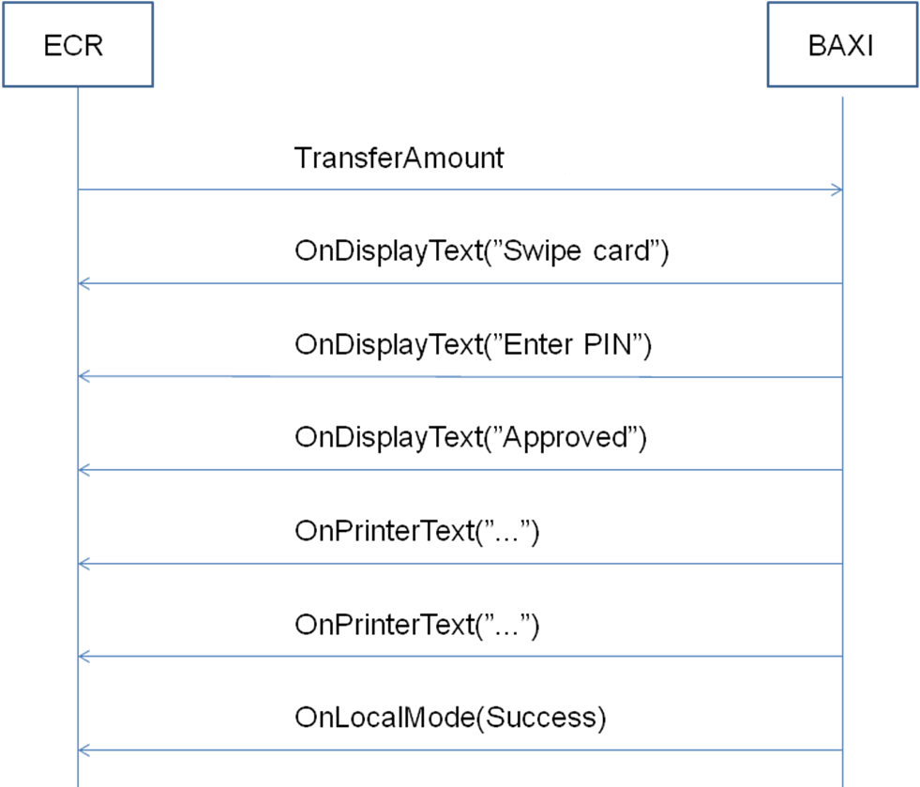

Unsuccessful purchase
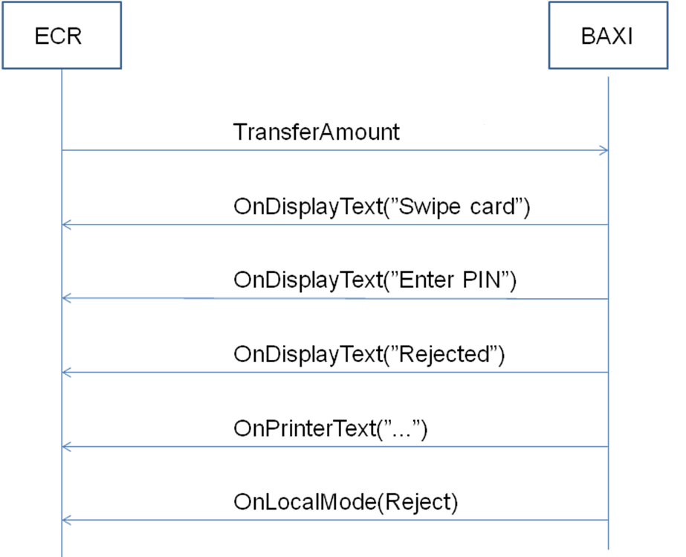

Purchase with an error situation

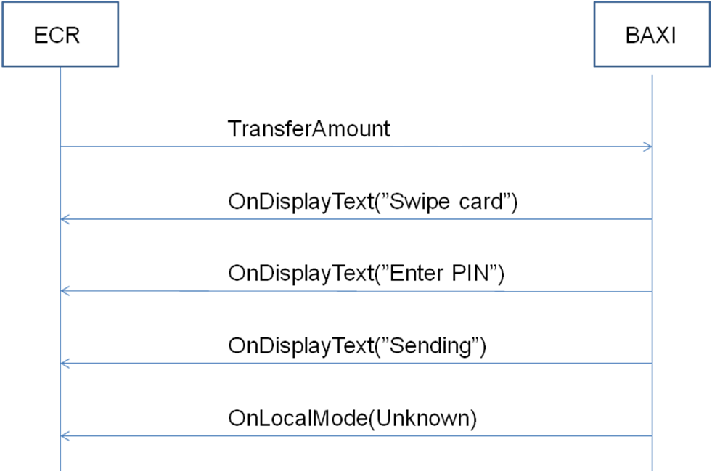

Appendix C – Fallback on I9500
Baxi Log:-
15:14:27.8448638 : Fire_OnTLDReceived :: 101300011- Card is inserted on Idle.
15:14:30.5436685 : *****************************************************
15:14:30.5436685 : SendTLD(REQ, 20000003001-20080003005-20020003001-20010000-) Get Customer Info request sent from ECR.
15:14:30.5436685 : ****************************************************
15:14:30.6372687 : Fire_OnStdRsp :: respContent = 00
15:14:36.3468787 : Fire_OnTLDReceived :: 101300010- Card is removed.
15:14:37.0800800 : Fire_OnDisplayText :: (1,1003) INDSÆT KORT “Insert Card” is displayed
15:14:44.6148932 : Fire_OnTLDReceived :: 101300011- Card is inserted
15:14:44.7708935 : Fire_OnDisplayText :: (1,1001) TAG KORTET “Remove card” is displayed
15:14:45.7536952 : Fire_OnTLDReceived :: 101300010- Card is removed
15:14:46.2216960 : Fire_OnDisplayText :: (0,0) LÆSEFEJL Mag swipe read failed. Could be card or card reader or improper swipe issue.
15:14:46.2840962 : Fire_OnDisplayText :: (0,0) PRØV IGEN “Read fail, try again” is displayed. Card was inserted again.
15:14:48.4837000 : Fire_OnDisplayText :: (1,1001) TAG KORTET “Remove card” is displayed. Card is removed.
15:14:49.7785023 : Fire_OnDisplayText :: (1,1003) INDSÆT KORT “Insert card” is displayed.
15:14:51.6193055 : Fire_OnTLDReceived :: 101300011- Card is inserted
15:14:51.7753058 : Fire_OnDisplayText :: (0,0) TAG KORTET DU “Take out card and try again” is displayed
15:14:51.8377059 : Fire_OnDisplayText :: (0,0) OG PRØV IGEN
15:14:52.5709072 : Fire_OnTLDReceived :: 101300010- Card is removed
15:14:53.1793083 : Fire_OnDisplayText :: (1,1003) INDSÆT KORT “Insert card” is displayed
15:14:54.2713102 : Fire_OnTLDReceived :: 101300011- Card is inserted
15:14:54.4273105 : Fire_OnDisplayText :: (1,1001) TAG KORTET “Remove card” is displayed
15:14:55.6753126 : Fire_OnTLDReceived :: 101300010- Card is removed. Fallback to mag swipe occurs here.
15:14:56.2837137 : Fire_OnDisplayText :: (0,0) INFORMATION Get Customer Info request sent to PSP.
15:14:56.3461138 : Fire_OnDisplayText :: (0,0) Vent
15:14:56.5489142 : Fire_OnTLDReceived :: 20000003001-20080003005-20020003001-200100194571990000139004937-2003000200- Response received from PSP.
15:15:09.6997373 : Fire_OnDisplayText :: (0,0) Afbrudt af kunde Cancel key pressed to abort the transaction.
15:15:09.7777374 : Fire_OnLocalMode :: D!050457199******4937;;2;321;;;;03;3:6;;;74114802;741148;Dankort;;E_3;;;;;; Local mode rejected sent to ECR.
15:15:14.8633464 : Fire_OnTerminalReady :: Terminal ready is sent to ECR.

Observations:
- The card has been inserted and removed 5 times in this scenario. (See marked in green).
- One successful retry means a successful read of mag swipe when card is removed. As seen above, the second retry was not successful (See marked in gray). This should not be counted in the total retries as per the functionality. Hence the total retries reduces to 4.
- As per the functionality, fallback retries count starts when a command is received from ECR. But the first try is before the Get Customer Info request which is not counted. So the total retries reduces to 3.

Appendix D – TLD not supported

Get encrypted card data

Call the function SendTLD() specifying a request encrypted card data:

SendTldArgs a = new SendTldArgs();
a.TldType = “REQ”;
a.TldField = “3007”;
Baxi.SendTLD(a);

Read the encrypted card data in the OnTLDReceived event, TLDReceivedArgs contents:

TldType : “RESP”
TldData : “3007” + US + “0015” + US + “000000000000000” + RS

Get encrypted card data and issuer ID

Call the function SendTLD() specifying a request encrypted card data and issuer:

SendTldArgs a = new SendTldArgs();
a.TldType = “REQ”;
a.TldField = “3008”;
Baxi.SendTLD(a);

Read the encrypted card data in the OnTLDReceived response, TLDReceivedArgs contents:

TldType : “RESP”
TldData : “3008” + US + “0015” + US + “000000000000000” + RS

Appendix E – Example integration code

Example test-gui made in JavaFX

As of version 0.2.5.0, NETS provides example integration code in form of a maven project. This project can be found in the directory “Example Code” in the jbaxi release package.

The example maven project uses javafx-maven-plugin and is done with the use of *.fxml files as the standard JavaFX procedure prohibits. The .fxml files can be found under:

“/jbaxi-fx-gui/src/resources/eu/nets/baxi/gui”

And it is recommended to use the Oracle JavaFX scenebuilder to view them.
The example project gives you a good insight in how all features in jBaxi work. The code is divided into dialogs for each functionality so that you can isolate the part that you will implement and study it thoroughly.

Before Import

Before you can use JavaFX with Java 7, you need to include it on your JDK's classpath. Use the following command (from anywhere):

mvn com.zenjava:javafx-maven-plugin:2.0:fix-classpath

Note: you must run this as a super user if your JDK is installed in a restricted directory (such as Program Files on Windows).

After running this command, JavaFX will now be on the default classpath of your JDK (like Swing, java.util, etc). Most IDEs need to be restarted to pick up the change.

As of Java 7 update 7, JavaFX is now 'co-bundled' with the JDK, so when you install the JDK, JavaFX is automatically installed with it. Oracle however have not fully finished this co-bundling and have left this in a somewhat annoying half-done state. The JavaFX libraries are included with the JRE, but are NOT put on the classpath by default. The above Maven command finishes the job so that your system is fully setup to use JavaFX.

Import, Package and Run

After the step in the previous chapter, you should be able to import the project into your desired IDE. Just remember to use Maven 3.1.1 or above. As you can see in the pom.xml file, the project has a dependency to the jbaxi.jar file so you will probably need to add it to your repository. Also, it has optional dependencies to the wrapper-module for communication, this is due to the Alone profile. Meaning, if you want to use the Alone profile, you should add the wrapper jar-files into your repository too.

After import, you should be able to package a new gui file simply by running:

mvn jfx:jar

and you should be able to run the gui by running the command:

mvn jfx:run

